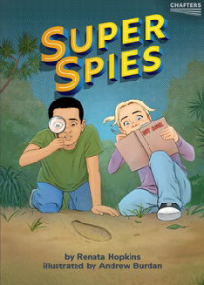

The Learning Progression Frameworks (LPFs) describe significant signposts in reading and writing as ākonga develop and apply their literacy knowledge and skills with increasing expertise from school entry to the end of year 10. This teacher support material describes the opportunities in Super Spies for ākonga to develop this expertise, in particular, reading for literary experience.
Super Spies
by Renata Hopkins illustrated by Andrew Burdan

Overview
Super Spies is part of the CHAPTERS series for ākonga in year
3. These early chapter books are designed to give ākonga the opportunity to read real chapter books, build reading stamina, and develop confidence and motivation for personal reading.
Ākonga in year 3 are likely to be reading at a range of levels on the colour wheel. This teacher support material provides suggestions for how to vary the level of support so that all ākonga can read and enjoy these books.

Super Spies features cousins Sophie and Manu, who also appear in the Ready to Read book The Thief. When Sophie and Manu hear strange noises in the forest, it’s time to get their spy kits and investigate the mystery.
It would be helpful if ākonga have read The Thief prior to reading Super Spies so they are familiar with the characters and setting. The Thief is levelled at Gold, so, to support ākonga who are not yet reading at this level, you could share-read it with them or have them listen to the audio recording.

Frequent use of dialogue, much of which is not explicitly attributed

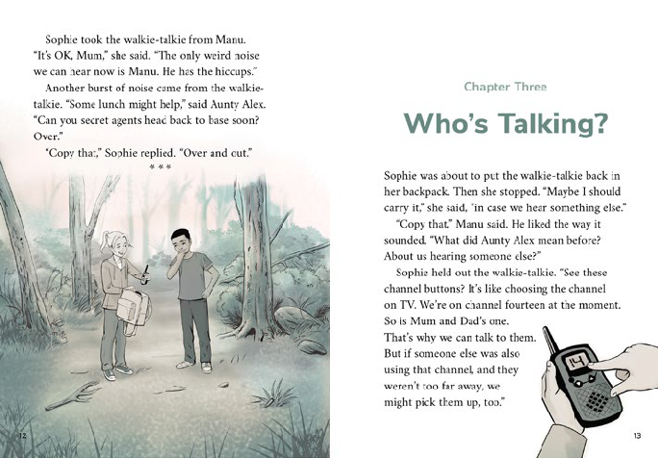Key text features
Super Spies has the following text features typical of chapter books.

The format of a chapter book, including a blurb on the back cover, a contents page, and chapter headings

A mix of explicit and implicit content that requires ākonga to make connections between ideas in the text and their prior knowledge (including knowledge from reading previous chapters) to ask questions, make and test predictions, and make inferences

Several pages with few or no illustrations, requiring ākonga to track information and visualise

Language features that provide opportunities for ākonga to build and apply their vocabulary knowledge:
A variety of sentence structures, requiring ākonga to attend to linking words and phrases and punctuation to clarify meaning
Shifts in time and place, and several characters and events
Some vocabulary that may be unfamiliar (for example, “clearing”, “weird”, “language”, “nuzzle”, “sensible”, “fifth marker post”, “pōtae”, “half listening”, “scent”, “stealthy”, “whining”, “slobber”, “muscle”, “muesli”, “Philippines”, “ulupong”, “poisonous”, “venom”, “scorpions”, “gorse”, “thistle”, “runaway”, “ute”), including several alternatives to “said” (such as “suggested”, “exclaimed”, “reported”, “wondered”, “promised”, “agreed”, “added”, “joked”), requiring ākonga to use their processing systems
- colloquial language and figures of speech (for example, “As if!”, “How’s everything…”, “picked up someone talking”,
“Keep our eyes peeled and our ears switched on”, “Check this out”, “veering off”, “ears swivelled”, “sprang into action”, “bailed up”)
- vivid descriptive language
- vocabulary associated with walkie-talkies and with spies (for example, “cellphone reception”, “aerial”, “channel”, “Secret Agent”, “Copy that”, “Over and out”, “in range”, “spy kits”, “gadgets”, “infra-red laser goggles”, “binoculars”, “sniffer dog”, “magnifying glass”, “footprint”, “spy log”, “clues”)
- the made-up words “hiccup-potamus”, “baa-lion” and the onomatopoeic words “SCREEEK!”, “AAARRRHHH”, “WHEEEG”, “HEEEURCH!”, “GROOOINK!”

Suggested initial reading purpose | Learning goals
What can ākonga expect to find out or think about as a result of reading this text?  - To find out how and why the children become “super spies” and what they discover  (Once they start reading, ākonga can set their own more specific reading purposes for each chapter.) | This text provides opportunities for ākonga to:  - enjoy reading a short chapter book and sharing their responses with others  - build confidence and motivation to read more  - make connections between their own experiences and information in the story to make predictions and inferences  - ask themselves questions and look for or think about possible answers  - monitor their reading, and when something is unclear, take action to solve the problem.
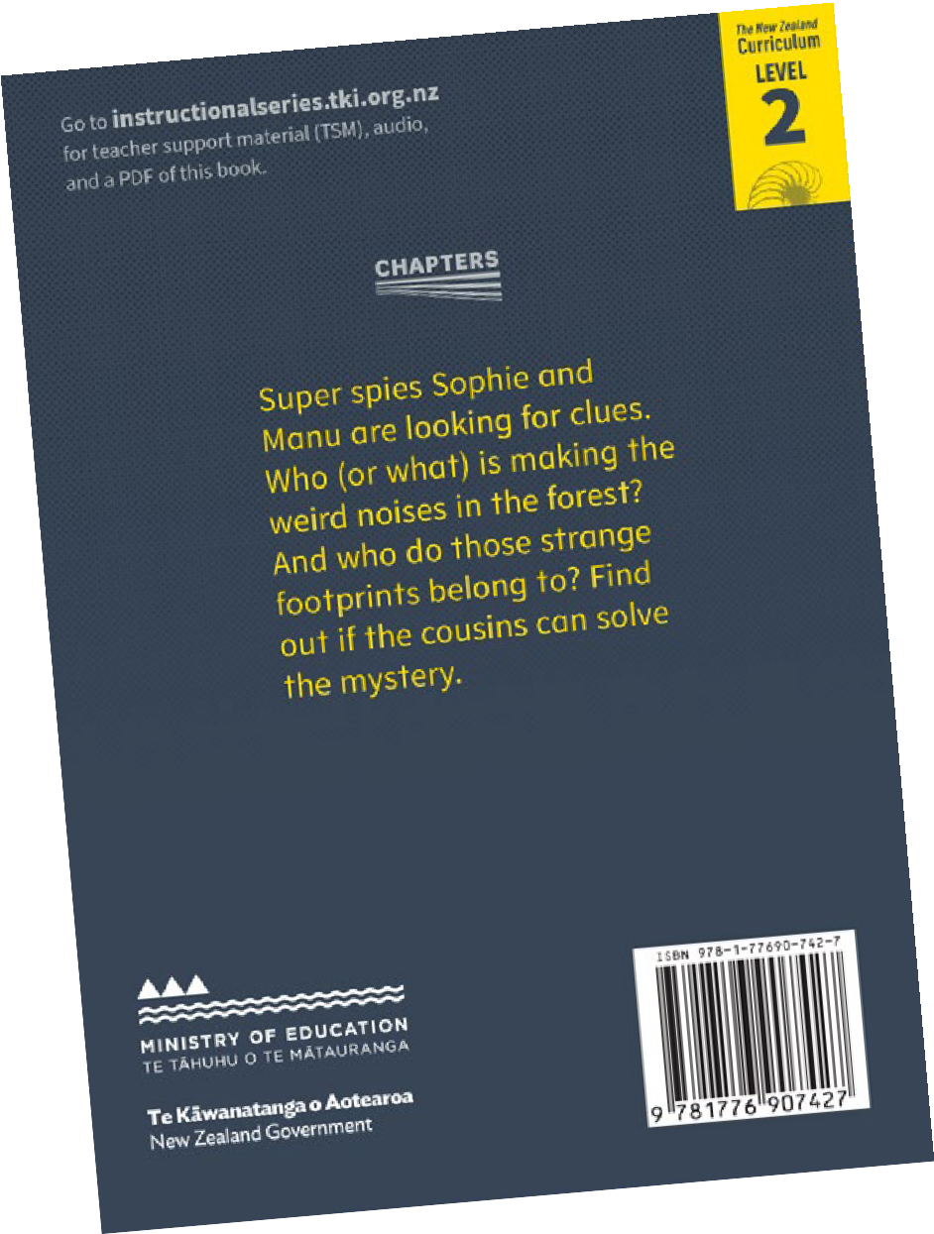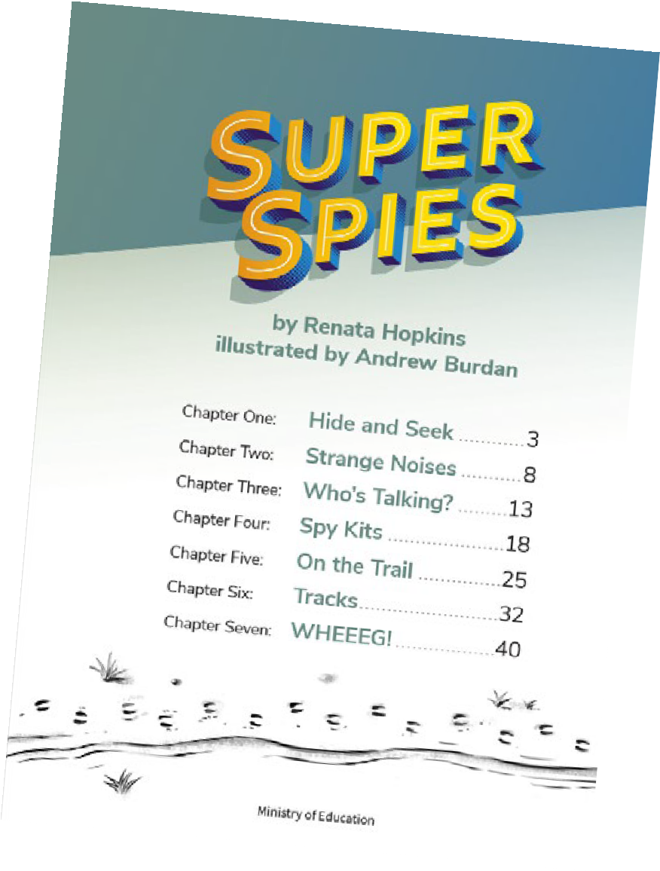
T
Introducing the book | Sounds and Words he Literacy Learning Progressions
Use your knowledge of your ākonga to ensure that the introduction to the book activates their prior knowledge and supports them  for a successful and enjoyable reading. Some ākonga will need more support than others. The following suggestions assume ākonga have read or listened to The Thief and are familiar with the main characters. Select from and adapt the suggestions as appropriate. | For English language learners, build confidence with new vocabulary by discussing the book before introducing it to the rest of the group. You could use the title and the cover illustration to introduce the two main characters (making connections to The Thief) and discuss what spies do. Then  browse through the Chapter One illustrations to clarify the bush setting and the game of hide and seek. Read the noise words in the page 7 illustration and enjoy speculating about what might be happening. Highlight, feed in, and clarify key vocabulary (in English or in their first language if possible). Try to repeat this sort of focused introductory discussion before each chapter.  - Tell ākonga that you have another book about Sophie and Manu for them to read. Enjoy reading the blurb together and speculating about the story. Use the title and cover illustration to generate ideas, for example, who, what, where? Discuss what spies are. What about super spies?  - Have ākonga use the chapter titles on the contents page to review their predictions and questions about the story. Together, set a purpose for reading the book or first chapter.  - Clarify how ākonga might read the book. For those reading below Purple and for English language learners, you could use a mixture of reading to and shared reading with ākonga following the text. Those reading at Purple or above might:  ‒ read the whole book independently over several days and then discuss it with you  ‒ read and discuss the first chapter, and then read the rest independently  ‒ read and discuss the story with you chapter by chapter. After each chapter you could support readers to summarise and discuss what has happened, share any difficulties they had and how they overcame them (or tried to), and make predictions for the next section.  - However ākonga read the book, ask them to pause at the end of each chapter to review their predictions or questions (either by themselves or with a partner) and to make a prediction or think of a question before they read the next chapter. Explain that making predictions and asking questions will help them think more deeply about what they are reading.  - Give ākonga sticky notes to record their ideas or mark aspects they find interesting or challenging, reminding them you will discuss these afterwards.

Reading the book independently
The suggestions in this section of the TSM are intended for students at Purple or above, who will be reading the book independently. For students reading below Purple, you could read the book to them or use a shared-reading approach for all or part of the text.
Chapter book reading is more personal and private than guided reading, with the main aim being for ākonga to follow the story and enjoy the reading experience. This means that at first, ākonga may be reading at a lower level of accuracy than would be expected for a guided- reading text. The initial role of the teacher is more to encourage than intervene. Challenges and errors can be addressed in the discussion and teaching opportunities after reading.
Examples of how you can support individual ākonga during the reading (if necessary):
- Remind ākonga to keep their reading purpose in mind and to make note of new predictions or questions at the end of each chapter.
- Prompt them to draw on their phonics knowledge and other word-solving strategies they can use, often in combination, for example:
‒ when decoding:
» recognising chunks or syllables within words (“Uni-verse”, “sen-si-ble”, “silver-beet”, “poi-son-ous”, “scor-pi-ons”)
» using their knowledge of variations in the sounds of letters and letter combinations (“camouflage”, “paused”, “rustled”, “reception”, “excitement”)
‒ when working out the meaning of words and phrases:
» using the context of the sentence and/or the surrounding sentences
» using the illustrations, the unfolding meaning of the story, and their prior knowledge
» reading on to look for further information.
If necessary, provide support with specific words, for example, reassuring them about irregular past-tense verb forms, colloquial language, or the made-up words.
Thinking, talking, rereading
Talking with ākonga about their reading, individually or in groups, helps build engagement and confidence. It also provides opportunities for you to gauge how ākonga are managing and to note any extra support they may need. These discussions may happen after each chapter, after reading the whole book, or at any other point that seems appropriate. Over time, ākonga may wish to lead their own discussions.
Select from and adapt the following suggestions according to your ākonga’s needs and responses to the reading.
For some suggestions, you may find it helpful to project the PDF of the book so that you can zoom in on relevant sections.
- Invite ākonga to share their responses to the chapter (or book). Is that what you thought would happen? What clues helped you? Discuss predictions they made or questions they thought of as they were reading.  - Reread the chapter or a section together, stopping to discuss and clarify aspects ākonga have marked. Support ākonga with pronunciation as necessary, encouraging ākonga to share their language knowledge, for example “pōtae” (paw-tie), “Jose”  (Ho-zay), “ulupong” (oo-lew-PONG – stress the last syllable). Remind ākonga they can hear these words in the audio version.  - Encourage ākonga to share any connections they have to similar experiences (for example, farms and farm animals, adventures in the bush or with cousins, hiccups, investigating strange noises, knowledge of the Philippines).  - Support ākonga to summarise the story (identifying the main things that happened and why). You could use the chapter titles as a guide to identifying the main event in each chapter. They could follow up by working in pairs to:  ‒ create a timeline of events, referring to the text and the map  ‒ identify the mysteries in the story and how Sophie and Manu solved them  ‒ identify a key event from each chapter and then use these to create a comic strip that includes a sentence and a speech bubble or a thought bubble in each frame.  For English language learners, using a dictogloss, verb story, or writing frame helps scaffold them into saying or writing their own summary of the story. See ESOL online for further information. | - Prompt ākonga to think critically:  ‒ Draw on what ākonga know about spies (for example, from books, TV, or games) and compare this with Sophie and Manu’s spying efforts (for example, the spy kits, how good they were at listening, making a map, finding clues). Is Super Spies a good title? How would you rate Sophie and Manu as spies?  ‒ How were the walkie-talkies important in the story? (Draw out ideas about keeping the children safe in the bush as well as being the catalyst for their spy adventures.)  ‒ Discuss ways the writer has made this story interesting (for example, making it a mystery and providing clues, the  description of the spy kit, the scary bits, the chase, the humour in Manu’s attempts to get rid of the hiccups and in Sophie  and Manu not listening properly to the information about Munchkin, having some words all in capital letters, and the vivid descriptive language.  ‒ Have ākonga share their responses to the children’s ideas on page 48. What do you think might happen next?  - Enjoy exploring vocabulary. You could focus on:  ‒ the made-up words “hiccup-potamus” and “baa-lion” and the onomatopoeic words (in capital letters) for the noises.  ‒ words and phrases associated with walkie-talkies or with spies. You could record examples on a chart and have ākonga add definitions and illustrations.

‒ the colloquial language and figures of speech. Use the  opportunity to clarify meanings, such as Manu’s thought, “As if!” or Sophie’s “Knock, knock” joke (both on page 4). This would be of particular benefit to English language learners.  ‒ how the descriptive detail makes the writing more exciting and helps the reader visualise, for example:  » adjectives (“sneaky”, “scratchy”, “weird”, “mysterious”, “silent”, “stealthy”, “poisonous”, “dangerous”, “horned”, “hairy”)  » descriptive verbs (“dived”, “peered”, “creep”, “glared”, “crouched”, “crackled”, “strained”, “solve”, “nuzzle”, “snoozing”, “waggled”, “hurled”, “bounded”, “shrugged”, “trotting”, “hushed”, “rustled”, “yelped”, “reassure”, “lolling”, “veering”, “swivelled”, “bolted”, “bleeped”) including the alternatives to “said”, such as “wondered”, “suggested”, “exclaimed”, “joked”  » adverbs (“hopefully”, “Suddenly”, “grumpily”, “nervously”, “slowly”).  Read the sections where the words appear and discuss the supports to their meaning, including punctuation such as question marks, exclamation marks, and dashes. Ākonga could act out  the meanings of some of the words or illustrate some of the written descriptions (for example, “Manu felt something nuzzle his hand”). You could create charts of favourite examples and encourage ākonga to add to them and enjoy using them in their own writing. | For English language learners, collocations (pairs or groups of words that go together naturally) may need to be explicitly taught. Examples in this text include “talk button”, “strange noise”, “secret agent”, “eyes fixed”, “flopped down”, “rolled his eyes”, “wide apart”. Learning these as chunks of language will help with fluency, phrasing, and overall comprehension. This could be done as a matching activity where ākonga pair up or group the collocations.  - As you discuss the text with ākonga, note any aspects that might need further instruction, perhaps as a mini-lesson or during shared writing. For example:  ‒ the use of irregular past-tense verb forms. Explicit teaching about this aspect of English is particularly important for English language learners. Explain that not all verbs in English have “ed” added in the past tense. Read and discuss examples from the story and list their present- and past-tense forms (wear/worn, creep/crept, freeze/froze, swing/swung, sweep/swept, spring/sprang). Create oral sentences together using the verbs.  ‒ ways of tracking the unattributed dialogue. Have ākonga read sections of dialogue aloud and support them to attend to the use of speech marks, new lines for new speakers, and context clues (who the characters are and what the previous person has said) to track who is speaking. Ākonga could use coloured highlighters on photocopied pages to make the unattributed dialogue clearer.

Encouraging further reading
- Ākonga can build their comprehension and fluency by rereading the book as they listen to the audio version.  Audio versions are particularly supportive for English language learners because, as well as clarifying pronunciation, they provide good models of the prosodic features of English, such as intonation and phrasing.  - Support ākonga to set up their own literature circle or book chat to discuss and share ideas about the book. (See Effective Literacy Practice in Years 1–4, page 102, for information about literature circles and Learning through Talk: Oral Language in Years 1–3,  page 69, for suggestions about how to support group discussions.) This could even be run online via Zoom or another platform.  - Provide opportunities for ākonga to work together on responses to the reading. For example, they could:  ‒ make maps  ‒ design a spy kit  ‒ act out parts of the story or record themselves reading sections of the text  ‒ write another adventure for Sophie and Manu. | - Set up a browsing box or book corner with other short mystery stories for ākonga to read (or reread) and enjoy, for example, The Crocodile’s Christmas Jandals (RTR shared); Scarlett’s Scarf  (RTR Purple); The Thief (RTR Gold); “Taniwha Trouble” (JJ 40); “Buried Treasure” – which also features a map (JJ 53); “Something Strange Going On” (JJ 46); “Zapped!”(published in four chapters in JJs 52–55), and easy-read chapter books.  - Join the class up to a national book chat.  - Ensure ākonga have time during the school day for personal reading.  - Help ākonga find other early chapter books in the school or local public library.  You can find further information at:  - The Instructional Series: CHAPTERS  - National Library Services to Schools: Reading engagement

ISBN 978-1-77690-744-1 (PDF)
ISBN 978-1-77690-745-8 (WORD)

