The Literacy Learning Progressions: Meeting the Reading and Writing Demands of the Curriculum describe the literacy-related knowledge, skills, and attitudes that students need to draw on to meet the demands of the curriculum.  Connected  Level 4  2020  Fostering Felines  by Rebecca Toms  The Learning Progression Frameworks (LPF) describe significant signposts in reading and writing as students develop and apply their literacy knowledge and skills with increasing expertise from school entry to the end of year 10.  Overview  This article demonstrates how students at Sir Douglas Bader Intermediate School designed a technological device to solve a community problem – how to care for the thousands of newborn kittens handed in to the SPCA each year. It encourages the reader to consider the issues, giving a model for how the same process could be applied to other problems.  A Google Slides version of this article is available at www.connected.tki.org.nz  This text also has additional digital content, which is available online at www.connected.tki.org.nz | 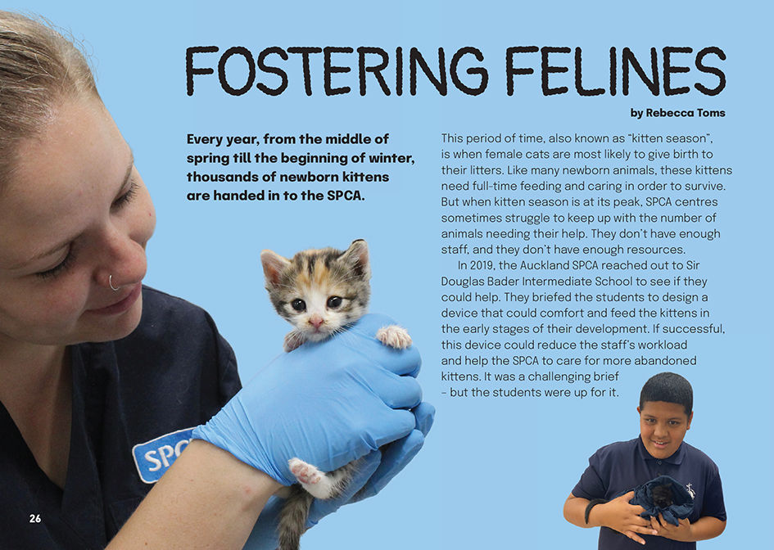
Curriculum contexts

TECHNOLOGY: Technological modelling  Level 4 – Students will understand how different forms of functional modelling are used to explore possibilities and to justify decision making and how prototyping can be used to justify refinement of technological outcomes. | Key technology ideas  - The design cycle typically involves identifying a need or opportunity, establishing the design brief, generating ideas, exploring and testing ideas, building and trialling prototypes, and developing and evaluating a final product.  - A design brief identifies the criteria that need to be addressed when designing and developing a technological product. These criteria help ensure that the final product is fit for purpose.
SCIENCE: Nature of Science: Participating and contributing  Level 4 – Students will use their growing science knowledge when considering issues of concern to them. | Key Nature of Science idea  Scientists:  - look for reliable evidence and consider what other scientists have found out when making decisions about a situation.
SCIENCE: Living World: Life Processes  Level 4 – Students will recognise that there are life processes common to all living things and that these occur in different ways. | Key science idea  - Kittens, like all baby mammals, rely on their mother’s milk for nourishment for at least the first few weeks of life. They also need warmth and shelter in these early weeks.

ENGLISH: Reading
Level 4 – Ideas: Students will show an increasing understanding of ideas within, across, and beyond texts.
Level 4 – Language features: Students will show an increasing understanding of how language features are used for effect within and across texts.

The New Zealand Curriculum

Meeting the literacy challenges

This article requires the reader to track the students’ process as they design their fostering device and to accept that, in real life, the process does not always follow a neat, linear progression. Complexity is added by including background information on the development of kittens.  There is some technical information in the explanations of the different design features, but most of the syntax and vocabulary is quite accessible. Sentence-level support and contextual clues explain new concepts such as “SWOT” and “CAD”.  Diagrams, photographs, and breakouts make for engaging content and offer different types of texts for building scientific literacy.  The following strategies will support students to understand, respond to, and think critically about the information and ideas in the text. | The instructional strategies below support students to meet the literacy challenges of this text. For each strategy, there are links to the relevant aspect of The Learning Progression Frameworks (Reading). The signposts on each of these aspects provide detailed illustrations on what to notice as your students develop their literacy knowledge and skills for different purposes in different curriculum areas.  You may wish to use shared or guided reading, or a mixture of both approaches, depending on the reading expertise of your students and the background knowledge they bring to the text.  After reading the text, support students to explore the activities outlined in the following pages.

INSTRUCTIONAL STRATEGIES

Building understanding  [LPF Reading: Reading to organise ideas and information for learning]  Have the students read the title and introductory text and SCAN the article to predict what it will be about. CHECK their understanding of “felines”. CLARIFY that this text is about students responding to a request from the SPCA to develop a device that can be used to comfort and feed newborn kittens.  PROMPT the students to make connections with their personal experiences of design.  This was a pretty special experience for these students. We’ve all had experience of design. It might be creating and using a plan like a sewing pattern or an architectural drawings. But there’s also design involved when people build a sandcastle on a beach, make a paper plane, or ice a cake. What are some design experiences you have had? What did they involve?  What things do people design? Do you know people who design things? Or maybe you have seen people designing things on TV. How do they go about doing it?  DISCUSS the term “design blueprint” and ask the students what they think this means. If they’re not sure, have them go online to research a definition. Clarify that by reading this article, we can find a “blueprint” for how to go about the design process.  PROMPT the students to draw on their prior knowledge and the clues in the introduction, headings, and images to predict the design process that the students in this article will follow.  The students have been given a design brief. What do you suppose comes next?  We can see that there is a whole lot of information about how kittens develop and the care and support they need. Why would the students need to know that?  What clues do we get from the headings?  What do you recall from your own experiences of design? | Create a flow diagram for the students to summarise the main ideas in the article and what they learn about the design process. They could complete their diagrams in small groups, using an app like Popplet. Initially, the diagram might look like the one below – as they read, the students can annotate it with the details of what the students at Sir Douglas Bader Intermediate School did to get to their solution.  Design process  Understand the brief  Research the needs  Explore and sketch ideas  Develop a prototype  Test, evaluate, and improve the design  Present the design  Have the students pause after reading page 27 to identify and list the needs of the end-users for this device.  - Do you think this provides enough information for the students to start work on their design?  What else might they need to know about?  Pause again after the students have read page 28:  - Were all your questions answered?  - The writer asks, “How would you design a device that satisfied all of Dr Walker’s requirements?” What do you think?  LIST the students’ suggestions so they can compare them with what the students actually tried.

Critical thinking about the main ideas  [LPF Reading: Acquiring and using information and ideas in informational texts]  Have the student groups share their diagrams and discuss what they have learnt. ASK QUESTIONS to prompt critical thinking.  Did the design process go smoothly? What went well? Where did the students strike problems?  Did the students develop features that you would have tried?  The students got help from two experts. How did that help in their design?  They used two different kinds of software. Is that something people would have done in the past? How do you think new technologies are affecting the way design is done?  Rachel encouraged the students to join their ideas up into a single device. Why do you think she suggested that?  What do you think about the reasons behind making the device? Was it worth doing?  The students still need to trial their device, but the writer says that they have a lot to be proud of. What can the students can be proud of?  What has this article taught you about the realities of the design process?  Have the students use what they learnt to agree on a blueprint for the design process and a set of tips for making it work well.  Dealing with unfamiliar vocabulary  [LPF Reading: Making sense of text: vocabulary knowledge]  DESIGN a cloze activity that students could use to check their understanding of some of the key terms and concepts involved in the design process. Explain that this is an activity and not a test, and they are welcome to return to the text to check their answers. You could create your own cloze or adapt the following example:  Students at Sir Douglas Bader Intermediate School were asked to design a _______ that could be used to care for _______ kittens. The brief included having a _______ and a _______.  The students began by making sure they understood the _______. They learned that the right level of care is _______. Sadly, some kittens are very sick. Their poor _______ can mean they have to be _______.  The students worked in groups to _______ and sketch their ideas. They used a computer program called _______ to make digital versions of their sketches. They used a _______ to cut the shapes out from cardboard. Then the students assembled their shapes into _______. | By completing a _______ analysis, the students found some common _______ in their first prototypes. They built more to test their ideas and make _______, and they got help from a _______ _______ _______. They used _______ called Computer Aided Design (CAD) to print out all the parts for their final prototype, the Mummy Dummy. It has furry, _______ fabric to keep the kittens comfortable. The bottles are down low so that the kittens lie _______ to feed.  If necessary, you could give the students the words below as a scaffold for completing the activity. Make sure you reorder them! It’s fine if they use different words, so long as the meaning makes sense.  “device”, “orphaned” (or “abandoned”), “brief”, “crucial”, “prognosis”, “litterbox”, “feeder”, “euthanised’, “brainstorm”, “sketches”, “Tinkercad”, “laser cutter”, “prototypes”, “SWOT”, “weaknesses”, “improvements”, “product development engineer”, “software”, “machine-washable”, “feeder”, “prone”  Extension  The students could make up their own cloze activities for their peers to complete.

The Learning Progression Frameworks
The Literacy Learning Progressions
Effective Literacy Practice: Years 5–8

Illustrating the key ideas

Identifying a need, generating ideas, building, trialling and evaluating prototypes are part of the design cycle.  A design brief identifies the criteria that need to be addressed when designing and developing a technological product. These criteria help ensure that the final product is fit for purpose. | 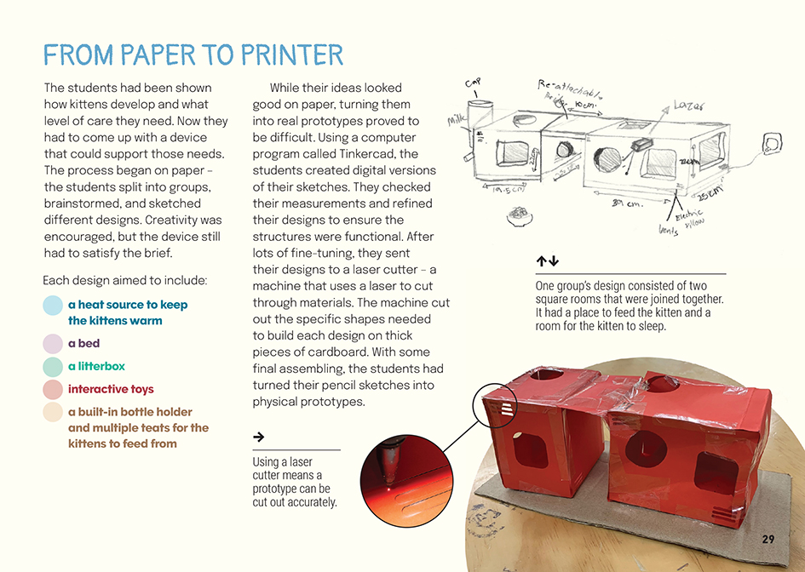
Identifying a need, generating ideas, building, trialling and evaluating prototypes are part of the design cycle.  Identifying a need, generating ideas, building, trialling and evaluating prototypes are part of the design cycle. | 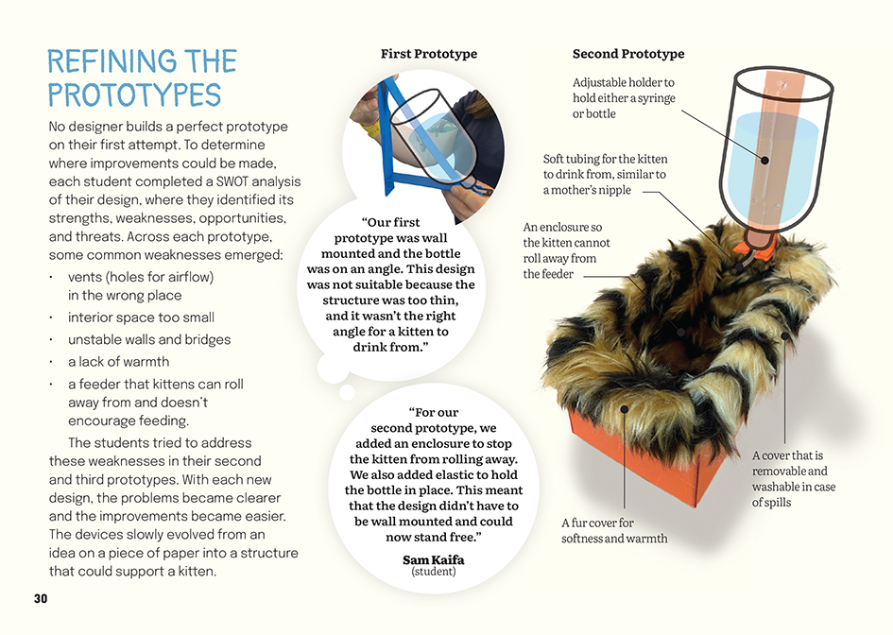

Learning activities – Exploring the
science and technology

Activity 1 – Furthering the feline-fostering designs  The writer suggests that students may have their own ideas for a kitten-fostering device. Your students may want to develop a whole new design, or they may have ideas for modifying and improving the prototype developed by the students at Sir Douglas Bader Intermediate School. Have the students work in small groups to refresh their memories and spark new ideas.  - What do you think might be missing from the students’ design? How would you fix this?  - Remember the ideas you suggested for fulfilling Dr Walker’s brief? How did they compare with the ideas the students in the article tried? Do you think your ideas might have worked?  - The writer tells us that the students ran out of time to add a heating source to their design. She asks how you would do it if you were them. What do you think?  Review what the students have learned about the design process and effective ways of approaching design. Have them think about their ideas and how they can use what they have learned to approach their own design journey. Talk through the different phases of the process and the people and tools that could help them.  - What do we need to find out about to take our ideas further? Where can we find answers to our questions?  - Who could help us? When would be the best points to have them come into the design process?  - What are some digital technologies we would try to help us develop our designs?  - The intermediate school students hadn’t trialled their design, and the writer tells us that they would need to be careful to make sure their trial doesn’t harm the kittens. How could we design a trial that is safe and gives us the answers we want?  The following ideas could help suggest a direction for the students’ design:  - The students could identify people in the community with expertise who could help them complete a prototype. There may be companies who have tools or materials that could be used to build them.  - The students could investigate the properties of different materials for covering the mother cat device. This could be supported using learning activities from books 5 and 48 in the Building Science Concepts series (see Resource links below).  - The students could use a micro:bit to build an alarm that will go off if the temperature goes below 23 degrees or set up a timer for feeding.  - The students could read “Maths Craft” (Connected 2019) and explore ways of using mathematical knots to assemble the Mummy Dummy and hold the bottles in the correct place. | The following activities and suggestions are designed as a guide for supporting students to explore and extend their content knowledge across the learning areas. Adapt these activities to support your students’ interests and learning needs.  - The students could read “To Build a Bot” (Connected 2018) and consider how to introduce robotic technology into the Mummy Dummy.  - The students could read “The Cardboard Cathedral” (Connected 2014) to learn more about technological innovation, the design process, and the issues around using cardboard in construction.  When the students have worked through their design process, support them to reflect on what they have learned. Go back to the flow diagram they created during the reading.  What have we learned about design that we could apply to other situations? What situations?  How might our learning help us in the future? How might it help others?  How might we now refine our design blueprints and guidelines?  Preferably, the students will be able to complete the entire design cycle, presenting it for use in the real world. However, if, like the students in the article, they are not able to do this, make sure they take notice of what they did achieve, and take pride in it.  Activity 2 – Responding to need  Review page 32 and the questions about issues and challenges in your community. Have the students think, pair, and share their ideas about these. Have them use their ideas to design a survey and prompt critical and creative thinking about how they could help solve a local problem using a design process. Encourage the students to think beyond their own needs to those of their whānau, school, and neighbourhood or district. Where possible, have them interact directly with the people who have the problems they would like to resolve.  Support the students to clarify the need, establish the design brief, generate ideas, explore and test ideas, build and trial prototypes, and present their final designs. As with Activity 1, begin the process with reflection on the design blueprint and guidelines developed during the reading and finish it with reflection on how engaging thoughtfully in this process helps us to engage in our world.  Note that the problem or issue does not have to be as complex as the one addressed by the students at Sir Douglas Bader Intermediate School. Fun alternatives to spark thinking, could include:  - “We have too many feijoas. How could we turn them into a food product that people will buy and enjoy?”  - “I keep sleeping through my alarm. Could you please build me an alarm that will wake me up properly but doesn’t scare the heck out of me?”

Extension
Prompt the students to think about their place in the world as citizens and the role of technology (in its broader sense) in helping us to contribute to our local communities. Students may raise issues of their own as they work through the design process. You could also spark debate with statements like these:
- “It is a waste of time for young people to have to fix problems that have been made by adults.”
- “If there is a problem, there is always a way that technology can solve it.”

RESOURCE LINKS

Connected and School Journal  “Maths Craft”, Connected 2019, Level 4, Seeing Beyond  “Kauri Dieback”, Connected 2017, Level 4, Where To Next?  “To Build a Bot”, Connected 2018, Level 3, Cracking the Code  “The Cardboard Cathedral”, Connected 2014, Level 2, How Do You Know?  Building Science Concepts  Book 5: Fur, Feathers, and Bark: Animal and Plant Coverings  Book 48: Fabrics: Origins, Properties, and Uses  Science Learning Hub  Introducing innovation: https://www.sciencelearn.org.nz/resources/1699-introducing-innovation  About innovation (video): https://www.sciencelearn.org.nz/videos/1018-about-innovation  SPCA  Home page: https://www.spca.nz/  Kitten season 2019: https://www.spca.nz/news-and-events/news-article/kittenseason2019  A day in the life of a bottle-feeding kitten foster parent: https://www.spca.nz/news-and-events/news-article/bottlefeedingfosterparent | Other  Medium.com: What is design thinking? (and what are the five stages associated with it?): https://medium.com/@bhmiller0712/what-is-design-thinking-and-what-are-the-5-stages-associated-with-it-d628152cf220  Explaining laser printing (video): https://vimeo.com/128058432  Kitten development timeline: https://www.royalcanin.com/nz/cats/kitten/kitten-development-from-birth-to-adulthood  YouTube: OneNews: SPCA struggling to cope with number of unwanted cats and kittens being dumped: https://www.youtube.com/watch?v=eARVBkVjmuU  BBC micro:bit: https://microbit.org/  Popplet: https://www.popplet.com/

