Making Scents
by Philippa Werry
Connected
Level 2
2020

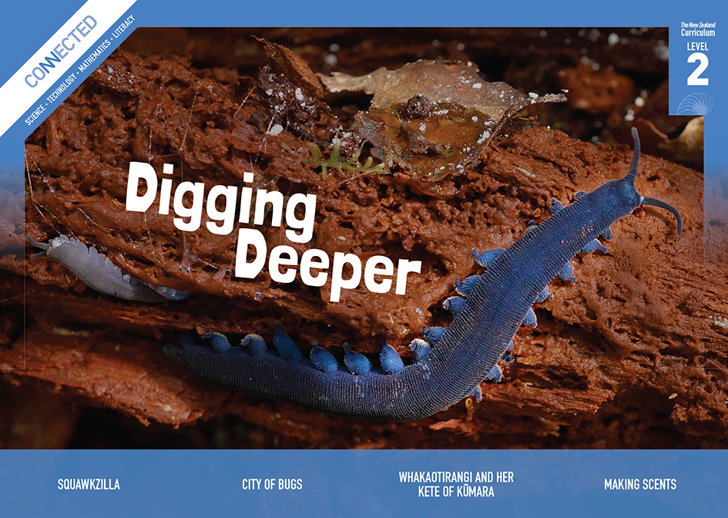
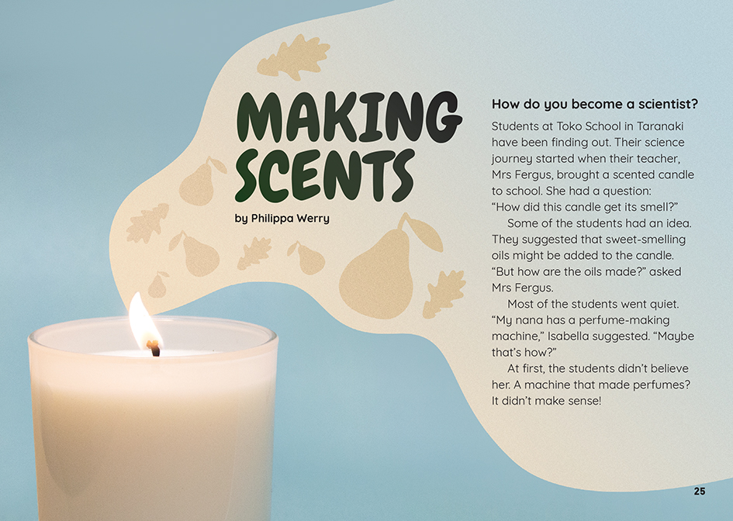
The Literacy Learning Progressions: Meeting the Reading and Writing Demands of the Curriculum describe the literacy-related knowledge, skills, and attitudes that students need to draw on to meet the demands of the curriculum.
The Learning Progression Frameworks (LPF) describe significant signposts in reading and writing as students develop and apply their literacy knowledge and skills with increasing expertise from school entry to the end of year 10.

Overview
This article follows a class project that students conducted after their teacher challenged them to find out how the smell gets into a scented candle. In the process, they learned about distillation, states of matter, and what it takes to become scientists and technologists.
A Google Slides version of this article is available at www.connected.tki.org.nz
This text also has additional digital content, which is available online at www.connected.tki.org.nz
Curriculum contexts

SCIENCE: Nature of Science: Investigating in science  Level 2 – Students will extend their experiences and personal explanations of the natural world through exploration, play, asking questions, and discussing simple models. | Key Nature of Science idea  Scientists:  - can use known processes like distillation to explore and find new materials from plants and other living things that may have properties useful for humans.
SCIENCE: Material World: Properties and changes of matter  Level 2 – Students will observe, describe, and compare physical and chemical properties of common materials and changes that occur when materials are mixed, heated, or cooled.  SCIENCE: Material World: Chemistry and society  Level 2 – Students will find out about the uses of common materials and relate these to their observed properties. | Key science ideas  - Materials have different physical properties, such as colour, smell, viscosity, and freezing and boiling points. We can use these properties to help separate, purify, and identify substances.  - We use materials for different purposes according to their different physical properties.
TECHNOLOGY: Nature of Technology: Characteristics of technological outcomes  Level 2 – Students will understand that technological outcomes are developed through technological practice and have related physical and functional natures. | Key technology ideas  - Research can inform technological development (for example, finding out how a still works to research scents).  - Technological outcomes are tested for their effectiveness (for example, by experimenting with different plants to find their scents).

ENGLISH: Reading
Level 2 – Ideas: Students will show some understanding of ideas within, across, and beyond texts.
Level 2 – Language features: Students will show some understanding of how language features are used for effect within and across texts.

The New Zealand Curriculum

Meeting the literacy challenges

The main literacy demands of this text arise from the relatively sophisticated concept of distillation, which requires an understanding of different states of matter. However, as the reader is exploring the topic alongside the students in the text, it makes the science concepts more accessible. The article assumes little prior knowledge, and the writer takes time to explain, and then reinforce, each new idea.  The text includes two procedures, with one supported by diagrams and the other by photographs. There is some subject-specific language, but a limited set, and it is repeated throughout the article. There are plenty of short sentences and paragraphs, and the narration has a chatty tone to keep the reader engaged.  The following strategies will support students to understand, respond to, and think critically about the information and ideas in the text. | The instructional strategies below support students to meet the literacy challenges of this text. For each strategy, there are links to the relevant aspect of The Learning Progression Frameworks (Reading). The signposts on each of these aspects provide detailed illustrations on what to notice as your students develop their literacy knowledge and skills for different purposes in different curriculum areas.  You may wish to use shared or guided reading, or a mixture of both approaches, depending on the reading expertise of your students and the background knowledge they bring to the text.  After reading the text, support students to explore the activities outlined in the following pages.

INSTRUCTIONAL STRATEGIES

Exploring the main ideas  [LPF Reading: Acquiring and using information and ideas in informational texts: Reading to organise ideas and information for learning]  TELL the students the title and, after showing them the image on the first page, ask them to predict what the article is about. ASK if they know the name for this kind of wordplay, and let them know that there is another pun to come!  DISCUSS the fact that scientists and technologists, like readers, must ask questions, make predictions, and search for answers. They do this before, during, and after reading a text, conducting an investigation, or designing a technological product. Construct a table the students can use to record the questions, predictions, and answers that emerge as they read this article.  Questions Predictions Answers  Before the reading  During the reading  After the reading  EXPLAIN that this article recounts the experience of students whose teacher brought a scented candle to school and asked them how it got its smell. (It may help to have a scented candle ready for your own students to smell.) Invite them to share what they think the answer would be. MODEL how to use the table to record the initial question and the students’ predictions. | Scan the text and IDENTIFY aspects of the structure that will help the students navigate the text, such as the subheadings, sections, photographs, and diagrams. The students will notice that while the main body of the text addresses the question about smells, there is also a bigger question about how to become scientists and technologists, which is returned to in the final section. Have the students predict what the answers to this question might be and RECORD their answers on their table.  As the students read, continue to PROMPT them to ask questions and make predictions. Encourage them to go beyond the text to make connections to their lives and the local environment.  I wonder … what a perfume-making machine might look like.  These students got lots of expert help. I wonder whether anyone in our community knows a lot about distillation.  After the reading, REVIEW the completed tables. Have the students identify any remaining questions and DISCUSS how they could be addressed.  Using visual features to understand technical information  [LPF Reading: Making sense of text: using knowledge of text structure and features]  PROMPT the students to unpack the diagram on how a still works.  What does this diagram show? How can you tell?  Why are there numbers? How do the numbers in the written text relate to the numbers on the diagram?  How do the labels help you to read the diagram?  There are photographs of stills on page 28. See if you and your partner can use what you learned from the diagram to name the parts on these stills?  What helped you most in reading this diagram – the picture or the words?

Meeting the literacy challenges

Introduce the symbols used in flow charts and MODEL how to rework this diagram as a flow chart. You could simply sketch this or use an app, such as those suggested by MindTools. Have the students work in pairs to create flow charts for making a distillate. They can then critique each other’s flow charts. Alternatively, this could be a shared activity with you providing focused support for particular students or groups.  Dealing with technical vocabulary  [LPF Reading: Making sense of text: vocabulary knowledge]  Acknowledge that there is a lot of scientific vocabulary in this article. DISCUSS the ways the writer helps us to understand the scientific words, particularly through explanations and diagrams. Remind the students that we can also look for the meaning in parts of words and in word families.  Challenge the students to organise the following words into word families, identifying and explaining the root words: condenser, condensation, distillate, distilling, still, distils, distilled, distillation, vapour, evaporation, maceration. Note that the word “still” is tricky because most students will know it only as an adverb or adjective, and online dictionaries do not always give its definition as a noun. They can use this table to help identify the word families. | Root word Meaning Related words  PROMPT the students to use their word-attack skills to break the word “hydrosol” into its parts and identify their meanings.  What are some other words that include either “hydro” or “sol”? What do they mean?

The Learning Progression Frameworks
The Literacy Learning Progressions
Effective Literacy Practice: Years 1–4

Illustrating the key ideas

Scientists use known processes like distillation to explore and find new materials from plants and other living things that may have properties useful for humans.  Materials have different physical properties. We can use these properties to help separate, purify, and identify substances. | 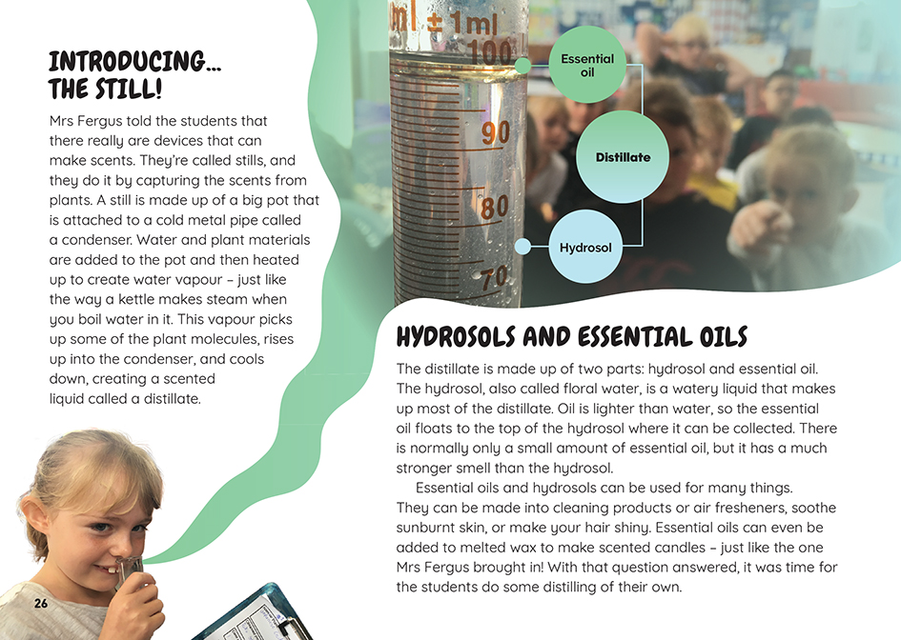  We use materials for different purposes according to their different physical properties.
Research can inform technological development.  Technological outcomes are tested for their effectiveness. | 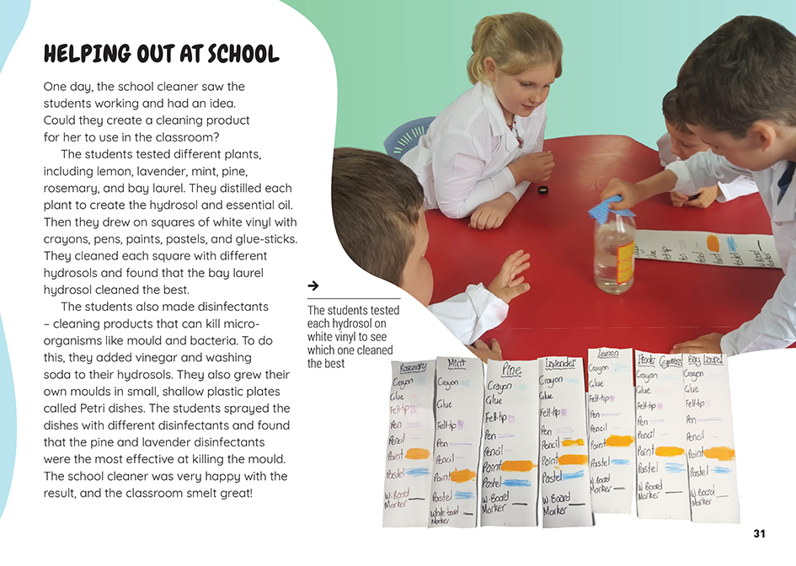

Learning activities – Exploring the science
and technology

Activity 1 – Scentsible science  Begin an investigation by having the students “switch on” their senses as they find and identify scented plants in the local area. With permission from the owners, and with guidance on how to take a cutting, the students could gather bundles of scented leaves and flowers. Have them describe each smell, creating a table with the plants’ names, a sketch or photograph, and a description. Then, in pairs or small groups, they could take turns being blindfolded and identifying the plant from its smell. Use this activity to prompt the students to ask questions that they could investigate with an experiment. The students may also have other questions from reading the article.  Questions for investigation might include:  How could the oils in the plants be used?  Can we predict which plants will produce the most oil?  What happens when you change the amount of water or plant product in the distillery?  Are there plants in our environment that could produce useful hydrosols and essential oils?  Are there other ways of distilling hydrosols and essential oils?  What are some other uses for distilled hydrosols and essential oils?  How do mana whenua use hydrosols and essential oils? What plants do they use? How do they extract the hydrosols and essential oils?  Are there some other ways we could use the processes of condensation and distillation?  Have the students reread the section on how to be a scientist. Prompt discussion of what they need to think about as they do their own scientific inquiry.  Who are experts in our community who could help us?  How are we going to record our measurements and compare our results?  What are some of the maths skills we might need to do this?  Have the students work with a local expert to plan an experiment that addresses their question. Make sure they keep careful records, including photographs. They could create a table to record their questions, predictions, and findings as they emerge. When they have completed their investigations, have the students share their results with others in a report that includes a diagram, a flow chart of the process, and photographs. | The following activities and suggestions are designed as a guide for supporting students to explore and extend their content knowledge across the learning areas. Adapt these activities to support your students’ interests and learning needs.  Activity 2 – Distilling it down  If possible, start this activity with a visit to a local essential oils distillery (if there is one in the community) to see it in action. Have the students design and build their own distillery. Work with mana whenua and other community experts to identify plants that contain hydrosols and essential oils that could be used to create useful products. Have the students use their distillery to experiment with different possibilities.  Have the students investigate how they could use these products to provide a community service or create a business, like the students at Toko School. This will require them to test their products and refine them to what people want.  Use the distilling experiment to reinforce the importance of taking careful and accurate measurements and keeping accurate records. This will provide an opportunity for the students to use maths to calculate the supplies they need, any profit, and to calculate the scale of their production to meet demand.  The students’ products will need to be packaged, labelled, and made appealing. If they are selling them, they will need to market them. They could incorporate eLearning and digital technologies for this, such as using 3D printing to make their packages (if you have access to one) or designing and building a website to sell their products. In this case, consider students’ progress in designing digital outcomes.  Encourage the students to think about the environmental sustainability of their products through each step of the process, from the plants they select to the process of distillation and on to packaging and distribution.  Extension  The class may like to reach out to Toko School to share what they have done and build a community of young scientists and technologists.

RESOURCE LINKS

Connected and School Journal  “Plants That Heal”, Connected 2, 2010, Working with Nature  “The Science of Rongoā”, Connected 2015, Level 3, Fact or Fiction  “A Sweet Business”, School Journal, Level 3, November 2016  Building Science Concepts  Book 15: Where’s the Water?: Water’s Forms and Changes in Form  Making Better Sense of the Material World  Science Focus: Water (pages 23–33)  Science Learning Hub  Building science capital at Toko School: https://www.sciencelearn.org.nz/resources/2778-building-science-capital-at-toko-school  Distilling oils and hydrosols: https://www.sciencelearn.org.nz/resources/2625-distilling-oils-and-hydrosols  Using an authentic context for teaching science: https://www.sciencelearn.org.nz/videos/1876-using-an-authentic-context-for-teaching-science  Visit to a lavender farm – case study: https://www.sciencelearn.org.nz/resources/2555-visit-to-a-lavender-farm-case-study | Other  Curious minds: Distilling down the science of scents: https://www.curiousminds.nz/stories/distilling-down-the-science-of-scents/  Science Friday: How to capture a scent: https://www.sciencefriday.com/educational-resources/how-to-capture-a-scent/  YouTube: Sci show: Do essential oils really work? And why? https://www.youtube.com/watch?v=5MJpurZ9ShI  Assessment resource banks: Flow charts: https://arbs.nzcer.org.nz/flow-charts  Creately: Flow chart software: https://creately.com/lp/flowchart-software/  MindTools: Flow charts: https://www.mindtools.com/pages/article/newTMC_97.htm  Learn how to make your own DIY essential oils: https://www.diynatural.com/diy-essential-oils/  Leaf TV: How to make an essential oil distiller from kitchen equipment: https://www.leaf.tv/articles/how-to-make-an-essential-oil-distiller-from-kitchen-equipment/

