The Literacy Learning Progressions: Meeting the Reading and Writing Demands of the Curriculum describe the literacy-related knowledge, skills, and attitudes that students need to draw on to meet the demands of the curriculum.  Connected  Level 4  2020  Foulden Maar: Fossils or Food?  by Ellen Rykers  The Learning Progression Frameworks (LPF) describe significant signposts in reading and writing as students develop and apply their literacy knowledge and skills with increasing expertise from school entry to the end of year 10.  Overview  This article explains the formation of Foulden Maar, the remains of an ancient lake formed by a volcanic eruption millions of years ago. As layers of silica-rich mud built up over thousands of years, it provided perfect conditions for fossilising the remains of plants, animals, and diatoms that fell to the bottom of the lake. However, the silica also has commercial value, including as an additive for duck and pig food. The article explores the perspectives of a range of stakeholders who have different opinions about the future of the maar. It prompts critical thinking and finishes with a call to social action.  A Google Slides version of this article is available at www.connected.tki.org.nz | 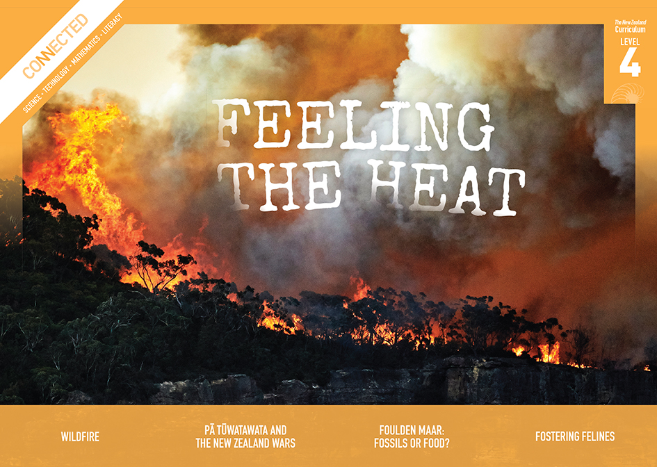  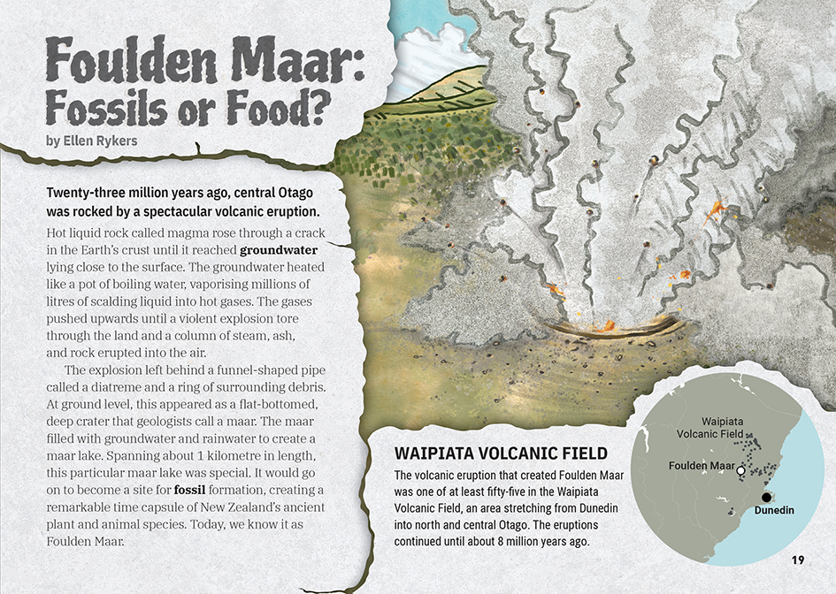
Curriculum contexts

SCIENCE: Nature of Science: Participating and contributing  Level 4 – Students will use their growing science knowledge when considering issues of concern to them; Students will explore various aspects of an issue and make decisions about possible actions. | Key Nature of Science ideas  Scientists:  - look for reliable evidence and consider what other scientists have found out when making decisions about a situation  - work within a cultural context where science influences and is influenced by societal responses.
SCIENCE: Planet Earth and Beyond: Earth systems  Level 4 – Students will develop an understanding that water, air, rocks and soil, and life forms make up our planet and recognise that these are also Earth’s resources. | Key science ideas  - There are processes that cause Earth to change over time.  - The processes that gradually change sediments into rocks also help fossils to form.  - Fossils are the preserved remains of living organisms or of traces of their activities.  - By discovering and studying fossils, we can find out about living organisms that were on Earth before there were people.  - Some fossil materials are valuable because they are used to make products that humans use.

ENGLISH: Reading
Level 4 – Ideas: Students will show an increasing understanding of ideas within, across, and beyond texts.
Level 4 – Language features: Students will show an increasing understanding of how language features are used for effect within and across texts.

The New Zealand Curriculum

Meeting the literacy challenges

The structure and content of this article are sophisticated, shifting from scientific explanation to an exploration of socio-scientific issues. Students are required to adjust their reading strategies to this shift. They must also synthesise information, specifically about the definition of a maar, the scientific value of the fossils preserved in Foulden Maar, and the values and perspectives of a range of stakeholders. The article finishes with a call to social action.  The article demands critical thinking as students weigh up the different perspectives and consider their personal response. Critical thinking is also required to notice that the perspective of the writer, while not stated directly, is implicit.  The article uses rich, descriptive language, including a great deal of subject-specific language. Contextual clues and sentence-level support is provided to explain some subject-specific words, but the article also relies on the reader having some prior knowledge. | The instructional strategies below support students to meet the literacy challenges of this text. For each strategy, there are links to the relevant aspect of The Learning Progression Frameworks (Reading). The signposts on each of these aspects provide detailed illustrations on what to notice as your students develop their literacy knowledge and skills for different purposes in different curriculum areas.  The following strategies will support students to understand, respond to, and think critically about the information and ideas in the text.  You may wish to use shared or guided reading, or a mixture of both approaches, depending on the reading expertise of your students and the background knowledge they bring to the text.  After reading the text, support students to explore the activities outlined in the following pages.

INSTRUCTIONAL STRATEGIES

Exploring the writer’s purpose  [LPF Reading: Acquiring and using information and ideas in informational texts: Making sense of text: using knowledge of text structure and features]  TELL the students that this article is about Foulden Maar. Show them where it is on a map and ASK them what, if anything, they know about it. Some students may be able to make connections with items they have read or heard about in the media.  ASK the students to read the title and PROMPT them to think about what it suggests about the author’s purpose and how the article might be structured.  What do you think when you read this title? What does it make you wonder?  What do you think the writer’s purpose is?  Given your prediction, how do you think this article might be structured?  Have the students scan the headings to check their predictions.  What did you find? Do you think you were right about the purpose of this article? What clues tell you that you were right or what clues have made you change your mind about the article?  So far, do you think your predictions about the article’s structure were correct? Why do you say that?  What do you think we will learn from this article? | Dealing with unfamiliar and scientific vocabulary  [LPF Reading: Making sense of text: vocabulary knowledge]  TELL the students that this text includes a lot of words that are likely to be unfamiliar, many of them related to fossils and volcanoes. PROMPT them to recall the strategies they can use to work out unfamiliar vocabulary, such as:  - looking at the context and thinking about the surrounding information  - finding root words  - drawing on their knowledge of word patterns and prefixes or suffixes  - making connections to their prior knowledge.  If the students have studied animal fossils or volcanoes before, REVIEW the specialised vocabulary they already know. Have them work in pairs to brainstorm what they know about these topics and the key words and record this in a Google doc. Have the pairs of students share their vocabulary and ideas with the rest of the class. Give them sticky notes to highlight new words as they find them in the text.  After reading the article, have the students move back into their pairs to check, update, and add to their definitions and explanations. PROMPT them to continue to add illustrations, explanations, and other information as they continue to explore the information and ideas in the article.
Critical thinking about language  [LPF Reading: Making sense of text: using knowledge of text structure and features]  PROMPT discussion about the features of scientific texts – for example, they are typically precise, formal, logical, condensed, and objective. If this is an area where students need additional support, consider using the Assessment Resource Bank item on the language of science (in the Resource links below) to create a graphic organiser they can use to identify examples in this text.  Have the students reread the text on the first page, this time thinking about the conventions of a scientific text.  What do you notice about the sentences, particularly the verbs?  What do you notice about the nouns and adjectives?  Do you think this article reads like a scientific text? Why or why not?  What is the same? What seems different?  If you scan the rest of the text, what else do you notice? | PROMPT them to notice that the writer uses:  - poetic language (such as alliteration, similes, and metaphors)  - many descriptive verbs, adverbs, and adjectives  - a direct appeal to the reader.  DISCUSS the purpose of each of these elements and why or why not they have a place in science writing. Move towards a discussion of why the writer wrote in this way, whether it worked, and whether it was justified.  Was this technique effective?  What do the techniques reveal to you about the writer’s point of view?  Are the writer’s choices appropriate?  Might you use these techniques in your own science writing? How might you use them?

The Learning Progression Frameworks
The Literacy Learning Progressions
Effective Literacy Practice: Years 5–8

Illustrating the key ideas

The processes that gradually change sediments into rocks also help fossils form.  Fossils are the preserved remains of living organisms or of traces of their activities. | 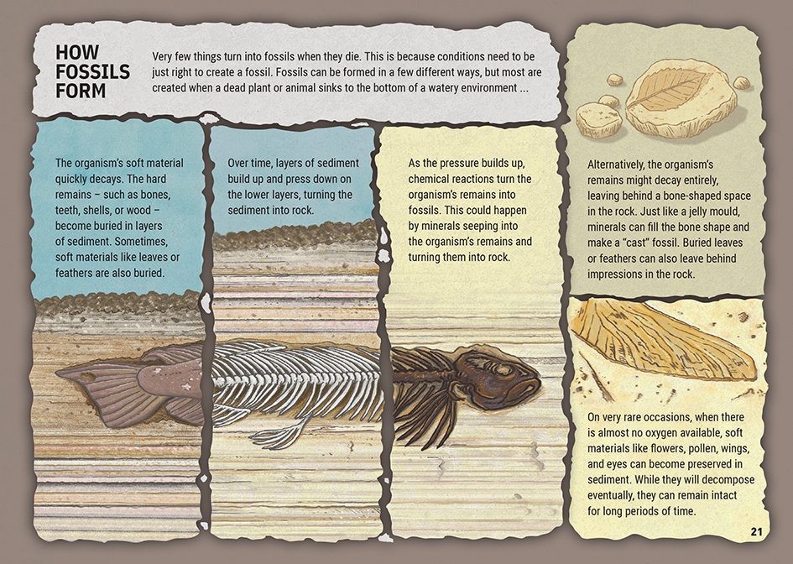  By discovering and studying fossils, we can find out about living organisms that were on Earth before there were people.
Some fossil materials are valuable because they are used to make products that humans use.  Scientists work within a cultural context where science influences and is influenced by societal responses. | 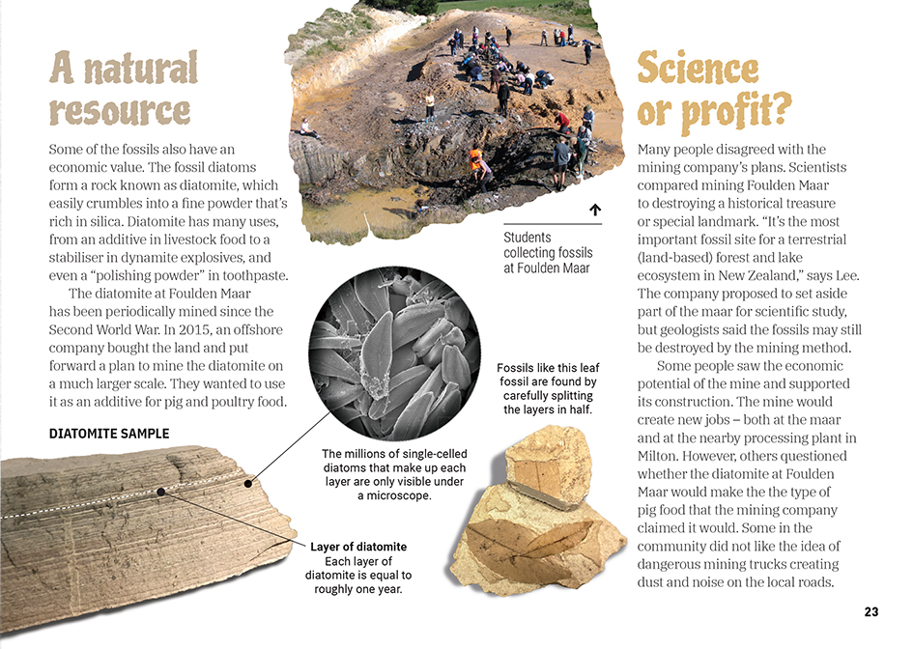

Learning activities – Exploring the science

Activity 1 – Fossils or food?  Have the students work in groups to consider the rights, responsibilities, and options of stakeholders in the decision making on Foulden Maar. Tell them that each student group is to take on the identity of one stakeholder group.  Prompt the students to make connections with the text to find out what it says about the perspectives of people in these groups, what they value, and their concerns. Then prompt them to go beyond the text and conduct online research to find out more about what people in their representative group think and believe about the maar and why. Encourage critical thinking about the ethics of the issue – balancing the value of scientific research with other values.  What makes it OK for scientists to dig into the maar? Why shouldn’t other people be able to do that?  Don’t jobs matter? Don’t animals need to eat?  Why not find a compromise?  Tell the students that a public meeting has been convened to debate the topic, “Foulden Maar: Fossils or Food?” Each group will be given three minutes to present their perspective about the future of Foulden Maar. After the first round of presentations, there will be a short break, then each group will have two minutes to respond to the other presentations. Finally, a vote will be taken on the best way forward.  At the end of this activity, discuss what the students have learned about making big decisions about the way we treat our environment. Emphasise the need to be respectful and realise that others can have good reasons for their opinions, even if we disagree.  Extension  The students could use the insights they have gained to take action on this issue or to learn about and take action on the future of a significant place in their local environment. | The following activities and suggestions are designed as a guide for supporting students to explore and extend their content knowledge across the learning areas. Adapt these activities to support your students’ interests and learning needs.  Activity 2 – Buried treasure  Understanding fossilisation  Begin a study of New Zealand fossils, fossilisation, and palaeontology with the opportunity for students to make a cast of a fossil. The GNS Science resource on fossils includes a lesson plan for doing this. Have the students compare the process for creating a cast with the way fossilisation is described in the article.  Draw the students’ attention to the statement that “conditions need to be just right to create a fossil”. Have them review the information in the article to summarise what the conditions are that make Foulden Maar such a treasure.  The Connected articles “Squawkzilla” (Connected 2020, Level 2, Digging Deeper) and “A New Zealand Crocodile” (Connected 2013, Level 3, Food for Thought) describe remarkable discoveries at St Bathans, which is only around 80 kilometres from Foulden Maar. Until recently, the site at Foulden Maar has not been nearly as well-known as the one at St Bathans. Have the students read one of these items and then read The Spinoff item in the “Resource links” below, working towards the understanding that while St Bathans has offered many treasures, the conditions at Foulden Maar suggest that it could hold even more discoveries.  Why does the writer of The Spinoff article claim that the discovery of the giant parrot at St Bathans “proves we have to save Foulden Maar”?  How does this affect your thinking about the importance of Foulden Maar?  Use suggestions from Building Science Concepts Book 41 Fossils: Digging up the Past to extend the students’ understandings about fossilisation and the insights we can gain from fossils.  - Why can fossils tell us about how living organisms change over time?  - Look outside our classroom window. From what you have read, what might we have seen if we’d been looking out there millions of years ago? [Some students may realise that in many places, those living organisms might have been sea creatures!]  Learning from fossils  The GNS Science lesson plans include opportunities for students to interact digitally with images of fossils. It also includes a map of where fossils can be found, and gives advice on how to go about a fossil hunt. Preferably, though, any fossil-hunting expedition would be guided by an expert. Alternatively, students may have fossils at home, or it may be possible to view them at a museum. Make the most of any opportunity for students to engage with fossils by using the GNS lesson plans on identifying and sorting fossils.
Digging for treasure  Have the students move into groups and give each group copies of one of the School Journal or Connected items listed in the “Resource links” below. Have them use what they learn from this and from their previous activities to create a job description for a palaeontologist who will work at Foulden Maar. The job description should include:  - the job title  - the employer’s name and what they do  - the purpose of the job  - main task and responsibilities  - educational requirements  - the personal skills, knowledge, and qualities the job requires  - any other requirements the students believe are important.  You may need to clarify that “qualities” in this instance refers to character traits (like determination) and values (like a belief in the importance of learning from history). Have the groups of students read each other’s job descriptions and decide which seems most complete and accurate. The students could then do a role play where some are on the appointment panel and others are applying for jobs.  Finish by reflecting on the rewards and challenges of digging for fossilised treasure. | Activity 3 – Geopark  Have the students explore what a geopark is and why they are created. Begin with the Waitaki Whitestone Geopark, then prompt them to discover others around the world.  Have the students use what they learn to develop a design brief and some concept designs for turning Foulden Maar into a geopark. They should work in groups, and their briefs should take into account cultural, educational, and economic considerations.  Who would be kaitiaki? How would we ensure the proper care of the site?  How could we do this in a way that recognises the rights and responsibilities of iwi?  How would the park support scientists to learn from the past?  How would it add to the local community? And how could the community be involved?  How would you control who goes where?  Have the students present their design briefs and concept sketches to the class for critique. Have them use the feedback to refine their ideas before using Minecraft to build a model of their proposed geopark.

RESOURCE LINKS

Connected and School Journal  “Squawkzilla”, Connected 2020, Level 2, Digging Deeper  “A New Zealand Crocodile”, Connected 2013, Level 3, Food for Thought  “The Tsunami That Washed Time Away”, Connected 2014, Level 3, Why Is That?  “Our Rocks Rock!”, School Journal, Level 2, April 2013  “New Zealand Dinosaurs”, School Journal, Level 2, November 2017  “Mary Anning: Fossil Hunter”, School Journal, Level 3, September 2012  “The Dinosaur Hunter”, School Journal, Level 3, September 2012  “The Past Beneath Our Feet”, School Journal, Level 3, May 2016  Building Science Concepts  Book 41: Fossils: Digging up the Past  Science Learning Hub  Foulden Maar: https://www.sciencelearn.org.nz/resources/2798-foulden-maar  Foulden Maar pinterest board: https://www.pinterest.nz/nzsciencelearn/foulden-maar/  Heritage scientist timeline – Joan Wiffen: https://www.sciencelearn.org.nz/resources/2426-heritage-scientist-timeline-joan-wiffen  Fossils: https://www.sciencelearn.org.nz/topics/fossils  Fossil correlation (activity): https://www.sciencelearn.org.nz/resources/1516-fossil-correlation  Fossil plants as paleoclimate proxies (video): https://www.sciencelearn.org.nz/videos/1464-fossil-plants-as-paleoclimate-proxies  GNS Science:  New Zealand fossils: https://www.gns.cri.nz/Home/Learning/Science-Topics/Fossils/NZ-fossils  Fossils: https://www.gns.cri.nz/Home/Learning/Science-Topics/Fossils  New Zealand fossil record file: https://www.gns.cri.nz/Home/Products/Databases/New-Zealand-Fossil-Record-File  National palaeontological collection database: http://data.gns.cri.nz/npc/catalogue/index.jsp  Reptile fossils from an unexplored valley: https://www.youtube.com/watch?v=nbVLCRkXsyU  Lesson plans: https://www.gns.cri.nz/Home/Learning/Science-Topics/Fossils/Lesson-Plans | YouTube  Foulden Maar fossil treasures, climate record and mining issues Nic Rawlence: https://www.youtube.com/watch?v=F7EDmNyoc9Q  National Geographic: Fossils 101: https://www.youtube.com/watch?v=bRuSmxJo_iA  Other  Save Foulden Maar petition: https://our.actionstation.org.nz/petitions/save-foulden-maar  FRED: The fossil record electronic database: https://fred.org.nz/index.jsp  The Spinoff: The giant parrot proves we have to save Foulden Maar: https://thespinoff.co.nz/science/17-08-2019/the-giant-parrot-proves-we-have-to-save-foulden-maar/  RNZ Nine to Noon: The New Zealand fossil record files: https://www.rnz.co.nz/national/programmes/ninetonoon/audio/2018762578/the-new-zealand-fossil-record-files  Te Ara: What are fossils?: https://teara.govt.nz/en/fossils/page-1  Otago Daily Times: Dunedin City Council poised to buy Foulden Maar: https://www.odt.co.nz/news/dunedin/dcc/dunedin-city-council-poised-buy-foulden-maar  New Zealand Geographic: Buried treasure: https://www.nzgeo.com/stories/buried-treasure/?source=homepage  Quarry and Mining: Mining Black Pearl: https://quarryingandminingmag.co.nz/mining-black-pearl/  Assessment Resource Bank: Language of science (specialised language): https://arbs.nzcer.org.nz/language-science-specialised-language  Enabling e-Learning: Using Minecraft as a tool for learning: https://elearning.tki.org.nz/Teaching/Future-focused-learning/Minecraft  UNESCO global geoparks programme: https://unesco.org.nz/programmes/global-parks-programme/  Waitaki Whitestone Geopark: https://www.whitestonegeopark.nz/

