The Literacy Learning Progressions: Meeting the Reading and Writing Demands of the Curriculum describe the literacy-related knowledge, skills, and attitudes that students need to draw on to meet the demands of the curriculum.  Connected  Level 4  2020  Wildfire  by Naomi Arnold  The Learning Progression Frameworks (LPF) describe significant signposts in reading and writing as students develop and apply their literacy knowledge and skills with increasing expertise from school entry to the end of year 10.  Overview  The article explores wildfires. It looks at what they are, what causes them, how they affect us, and how they are affected by the climate. In the process, it gives scientific explanations of some big ideas and processes, including climate change, carbon sinks, deforestation, adaptation, and feedback loops. The article ends by suggesting ways we can work together to reduce the risk of wildfires.  A Google Slides version of this article is available at www.connected.tki.org.nz | 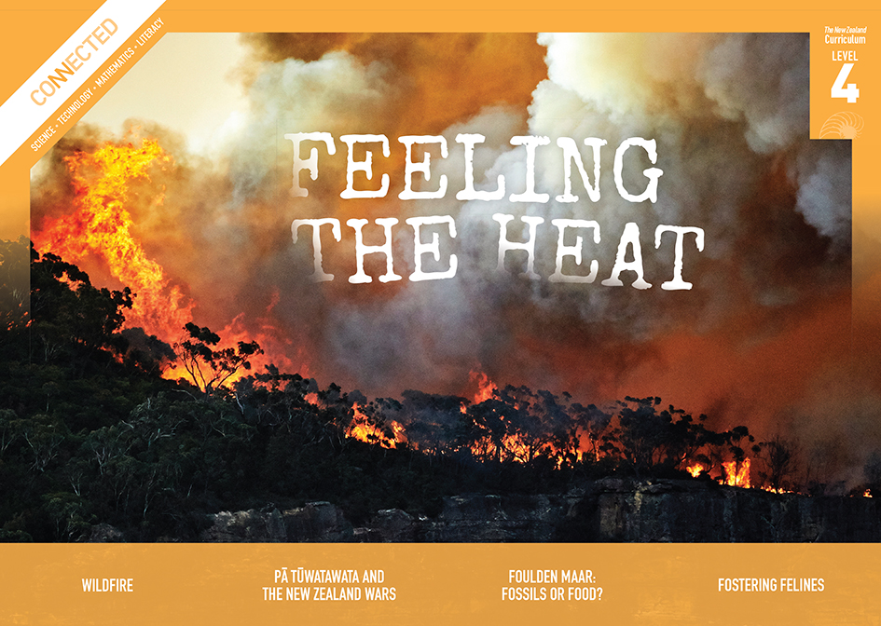  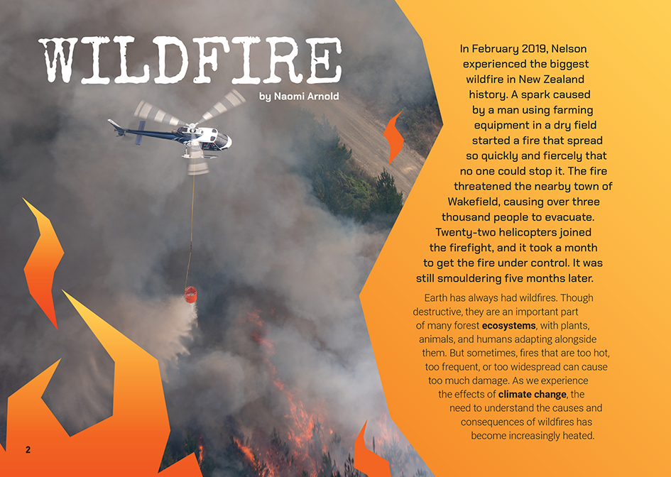
Curriculum contexts

SCIENCE: Nature of Science: Communicating in science  Level 4 – Students will begin to use a range of scientific symbols, conventions, and vocabulary.  SCIENCE: Material World: The structure of matter  Level 4 – Students will begin to develop an understanding of the particle nature of matter and use this to explain observed changes.  SCIENCE: Material World: Chemistry and society  Level 4 – Students will relate the observed, characteristic chemical and physical properties of a range of different materials to technological uses and natural processes. | Key Nature of Science idea  Scientists:  - use diagrams and other images to help represent and make scientific ideas clear. These representations are often developed for a particular purpose.  Key science ideas  - Fire is a form of chemical change in which oxygen reacts with a fuel, releasing energy as heat and light (the flames that we see).  - In a reaction, the atoms making up molecules are rearranged to form different molecules that have different properties.  - In the case of burning, the oxygen molecule combines with gases released from the fuel to form oxides. As fuel in wildfires is usually organic matter (that is, things that were once or are living), it is made up mostly of carbon and hydrogen, so the oxides formed are mostly carbon dioxide and water.

ENGLISH: Reading
Level 4 – Ideas: Students will show an increasing understanding of ideas within, across, and beyond texts.
Level 4 – Language features: Students will show an increasing understanding of how language features are used for effect within and across texts.

The New Zealand Curriculum

Meeting the literacy challenges

Part of the challenge of this article arises from the way it ranges over several important scientific concepts. However, students at this level will be familiar with many of the processes within these concepts. The bigger challenge is the need to track the many different angles explored in the article, including the causes and consequences of fire and the relationship between wildfire, deforestation, and climate change.  The article has a supportive structure, with the larger topic broken into logically sequenced sections. The syntax is relatively simple, and cause-and-effect relationships are clearly signalled.  The article introduces quite a few new terms but provides support with context clues, sentence-level explanations, and a glossary. The photographs and diagrams support and help to explain the text.  The topic is engaging and exciting, and all students will bring their prior knowledge to it. However, care should be taken as some students will have had personal experience of the impacts of fire. | The instructional strategies below support students to meet the literacy challenges of this text. For each strategy, there are links to the relevant aspect of The Learning Progression Frameworks (Reading). The signposts on each of these aspects provide detailed illustrations on what to notice as your students develop their literacy knowledge and skills for different purposes in different curriculum areas.  The following strategies will support students to understand, respond to, and think critically about the information and ideas in the text.  You may wish to use shared or guided reading, or a mixture of both approaches, depending on the reading expertise of your students and the background knowledge they bring to the text.  After reading the text, support students to explore the activities outlined in the following pages.

INSTRUCTIONAL STRATEGIES

Building knowledge  [LPF Reading: Reading to organise ideas and information for learning]  Tell the students the title of the text. Have them read page 2 to establish the focus of the article. Then have them construct a graphic organiser to record what they know about the causes of fires and their positive and negative effects, using information from their prior knowledge and from the text. After reading and discussing the text, have the students go back and update their charts, using a different colour.  Causes Effects  Positive Negative  Making sense of abstract concepts  [LPF Reading: Acquiring and using information and ideas in informational texts]  Have the students pause after reading the diagram’s introductory paragraph on page 3 and DISCUSS the term “diagram”. Check that the students recall that a diagram is a way of representing an idea, object, or process. Scientists create diagrams to communicate complex concepts and ideas.  This is a diagram of how fuel, heat, and oxygen work together to start a fire. Can you recall other scientific diagrams we have looked at? How did they work?  How does this diagram communicate the concepts? Is it effective? | PROMPT the students to share their experiences with trying to start, maintain, or contain a fire and have them use the information in the text to explain why they were or were not successful.  As the students read on, PROMPT them to notice other diagrams that show scientific ideas and processes (for example, rainfall in Australia).  - What do you know about this concept? How have you seen it explained?  - Who would use this sort of information?  - How do you think diagrams like this might help us in our everyday lives?  Thinking critically  [LPF Reading: Acquiring and using information and ideas in informational texts]  Use a jigsaw approach to explore the causes and consequences of fire and the relationship between wildfires, deforestation, and climate change. Have the students reread the article and take notes on their chosen area, then get back together with their group to share what they have learnt. They could create a chart, diagram, or use Google docs to share their learning.
Dealing with unfamiliar vocabulary  [LPF Reading: Making sense of text: vocabulary knowledge]  PROMPT the students to notice that this text has a lot of compound words. EXPLAIN that compound words are created when two words are joined together to create a single word with a different meaning. Often, the new meaning is linked to the meaning of the words that were joined. For example, farmland is joining “farm” with “land”, and it means a large area that is used for farming. Have the students list the examples of compound words in the text. | Working in pairs, have the students go through their list and break down the compound words on a chart like the one below. Support them to discover the links between the meaning of the words that make the compound and the new word.  ASK the students to share their thoughts about what they learned from this activity.  - A lot of people find that having a good understanding of compound words helps when they meet unfamiliar words. Do you think this is true for you? What makes you say that?
Compound word | Compound word meaning | First word | Second word | How do these words link to the new meaning?
wildfire | An uncontrolled fire that burns in the “wilderness” or rural vegetation | wild | fire | Wild – uncontrolled, and also root word of “wilderness”  Fire – burning, combustion

The Learning Progression Frameworks
The Literacy Learning Progressions
Effective Literacy Practice: Years 5–8

Illustrating the key ideas
Scientists use diagrams and other images to help represent and make scientific ideas clear.
Fire is a form of chemical change in which oxygen reacts with a fuel, releasing energy as heat and light.  Fuel in wildfires is usually organic matter (that is, things that were once or are living). | 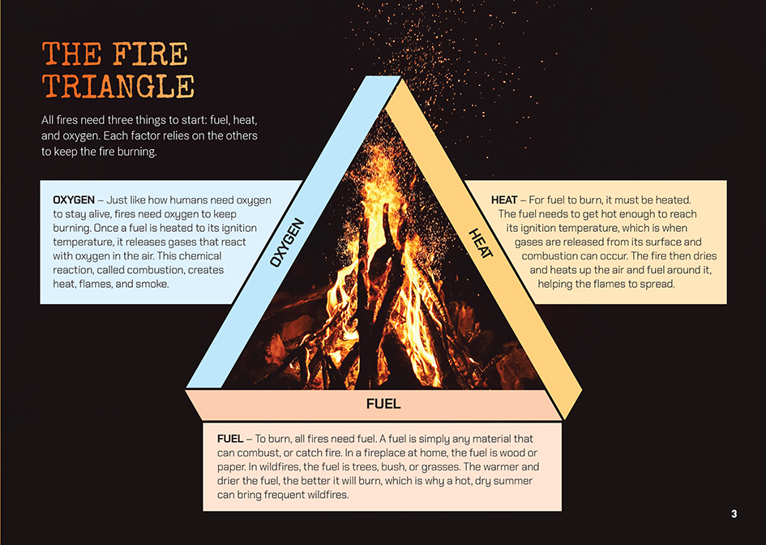  In a reaction, the atoms making up molecules are rearranged to form different molecules that have different properties.

Learning activities – Exploring the science

Note: As always, you will select and adapt activities that address your students’ interests, wonderings, and needs. If you chose to create a Wonder Wall, it will be important to be explicit about how the activities you select will help your students find answers to their questions.  Activity 1 – Models and feedback loops  Review the definition in the glossary of a positive feedback loop.  Do you think there might also be such a thing as a negative feedback loop?  How would it be defined?  What are some examples?  Review the features of an effective science diagram, prompting the students to recall what they know from other texts they have read. It may help to have some available. Challenge the students to use what they know about diagrams and feedback loops to draw a deforestation feedback loop  – a diagram that shows how losing trees in fires or to deforestation can create a positive feedback loop and how planting and growing trees could create a negative feedback loop.  Have the students read “Feedback” (School Journal, Level 4, 2020) to find out more about feedback loops and to compare the diagrams they have created with the one on page 39 of the School Journal article.  Have the students review the diagram of a fire triangle to notice and sketch the feedback loops that are part of that diagram (for example, the drier the wood, the hotter it will burn). Have them read “Trees, Seas, and Soil” (Connected, Level 3, 2020, Kaitiakitanga) and find examples of feedback loops. Prompt the students to notice that the “complicating factors” in the carbon cycle all involve feedback loops. Have them work in pairs to find how the feedback loops described in the text are represented in the diagrams.  Have the students move into groups to select one of the feedback loops involved in climate change, research it further, and develop a diagram that explains it. Discuss whether it is helpful to understand these relationships and why.  We know that scientists use diagrams and identify feedback loops to understand how things work and make predictions. But what use are they to the rest of the population?  Draw out the idea that understanding these models and feedback loops gives us the information we need to interrupt the processes that cause climate change and increase the risk of wildfires.  - The article claims that “just as humans can cause climate change, we can also change our behaviour to limit it”. Do you agree?  - Looking at our feedback loops, what are some changes we could make to reduce the impact of climate change and help prevent wildfires?  What are some changes we would like other people to make? | The following activities and suggestions are designed as a guide for supporting students to explore and extend their content knowledge across the learning areas. Adapt these activities to support your students’ interests and learning needs.  Have the students move back into their groups to investigate and evaluate options for action. Encourage them to consider potential actions across all the different levels mentioned in the article: personal, family, community, town, region, country, and planet. Have them select an audience and an action and develop a plan to persuade their audience to take action. The plan should help their audience better understand the issues and show how we can apply our knowledge to limit climate change and reduce wildfires.  Extension  Select activities from the Climate Change Learning Programme – Teacher Resource to further the students’ understandings of what climate change is and the role of science in both understanding it and learning how to mitigate its effects.  Activity 2 – Investigating combustion  Remind students that combustion – burning – is a chemical process that takes place when fuel is heated to a point where it releases gases that interact with oxygen to create heat, flames, and smoke. Light a candle and have the students observe and sketch the parts of the flame, identifying the melted wax, the blue tip, the glowing wick, the dark zone, and the luminous yellow zone.  Have the students use the Exploding Flour activity on the Science Learning Hub to understand how the surface area of fuel affects fire behaviour.  Use Building Science Concepts, Book 64 to:  - explore concepts related to the conservation of matter during physical and chemical changes  - reinforce the concept that gases are material substances, that is, they have mass  - explore concepts of energy transformation during the burning of carbon fuels.

Learning activities – Explore the technology

Activity 1 – Firefighting tools  Have the students review the information about the fire triangle and share what they know about other major fires in New Zealand or overseas. While the “Resource links” below include examples, wildfires are now so frequent that there are almost always major stories in the media.  Discuss the notion of adaptation – that people, like plants and animals, adapt to their environment so indigenous peoples in Canada and Australia developed the practice of cultural burning.  Introduce the term “mitigation” and explain that it is about fixing and reducing the impact of problems.  Cultural burning is an example of a technological practice that is used to mitigate the impact of fire. Can you think of others?  Prompt further wondering about the technological practices, tools, and materials used to mitigate the impact of fire.  - What clues does the fire triangle give us about how best to fight fires?  - I wonder whether more cultural burning might have helped prevent the fires in Australia.  - How do you know where to put a firebreak?  - How do you suppose people stay safe when they are fighting fire?  - What is fire retardant? How does that work? How do you use it?  - During summer, we often see signs telling us about the fire danger level. How do you suppose Fire and Emergency New Zealand knows what the danger level is? What technology do they use and how has it made them more effective and efficient?  - What is the best thing to do if a fire starts at school? | Have the students move into groups to research example fires, investigating what caused them, what the consequences were, and how they were fought. Aim for a spread of examples over time and place so that the students can compare how people in different cultural groups manage the risk of fire, how they fight it, and how different technological practices can be combined. Prompt them to keep the questions they raised in mind and seek possible answers.  Context:  Cause How it was fought Effects  Positive Negative  Discuss what the students learned about fire prevention and fighting.  What can we learn from the past about effective and ineffective ways of fighting fires?  How can new innovations help us do better?  Let’s think back to the questions we raised. What have we found to help answer them?  Have the students draw from what they have learned to create (or review) a fire protection plan for their home or school.

RESOURCE LINKS

Connected and School Journal  “Trees, Seas, and Soil”, Connected 2020, Level 3, Kaitiakitanga  “After the Fire”, School Journal, Level 3, November 2019  “Climate Change: Our Biggest Challenge”, School Journal, Level 4, June 2018  “Feedback”, School Journal, Level 4, May 2020  Building Science Concepts  Book 64: Candles: Investigating Combustion  Science Learning Hub  Deforestation: https://www.sciencelearn.org.nz/resources/1456-deforestation  Managing rural fire risk (video): https://www.sciencelearn.org.nz/videos/373-managing-rural-fire-risk  Project FuSE (video): https://www.sciencelearn.org.nz/videos/372-project-fuse  Managing fire risk in the outdoors: https://www.sciencelearn.org.nz/resources/743-managing-fire-risk-in-the-outdoors  Scientific modelling: https://www.sciencelearn.org.nz/resources/575-scientific-modelling  Exploding flour activity: https://www.sciencelearn.org.nz/resources/779-exploding-flour  Te Ara  Forest growth after fire: https://teara.govt.nz/en/forest-succession-and-regeneration/page-3  Fire and agriculture: https://teara.govt.nz/en/fire-and-agriculture  FENZ  Protect your home from outdoor fires: https://www.fireandemergency.nz/at-home/protect-your-home-from-outdoor-fires/  Forest management: https://www.fireandemergency.nz/farms-rural-properties-and-rural-businesses/small-forest-management/ | Other  Newshub: One year on from New Zealand’s largest wildfire in decades (video): https://www.newshub.co.nz/home/new-zealand/2020/02/nelson-fires-one-year-on-from-new-zealand-s-largest-wildfire-in-decades.html  BBC: Australia fires: A visual guide to the bushfire crisis: https://www.bbc.com/news/world-australia-50951043  Cool burns: Key to Aboriginal fire management: https://www.creativespirits.info/aboriginalculture/land/aboriginal-fire-management#Teaching_resources  WWF: Australian bushfires (video): https://www.wwf.org.au/what-we-do/bushfires#gs.bu5x7c  BBC News: California and Oregon 2020 wildfires in maps, graphics, and images: https://www.bbc.com/news/world-us-canada-54180049  The Guardian: New Zealand glaciers turn brown from Australian bushfires’ smoke, ash, and dust: https://www.theguardian.com/world/2020/jan/02/new-zealand-glaciers-turn-brown-from-australian-bushfires-smoke-ash-and-dust  Curriculum Online: Education for sustainability: Climate change learning programme – teacher resource: https://nzcurriculum.tki.org.nz/Curriculum-resources/Education-for-sustainability/Resources  Jigsaw Classroom: https://www.jigsaw.org/

