Connected
Level 3
2020

Life in Aotearoa New Zealand
by Matt Boucher
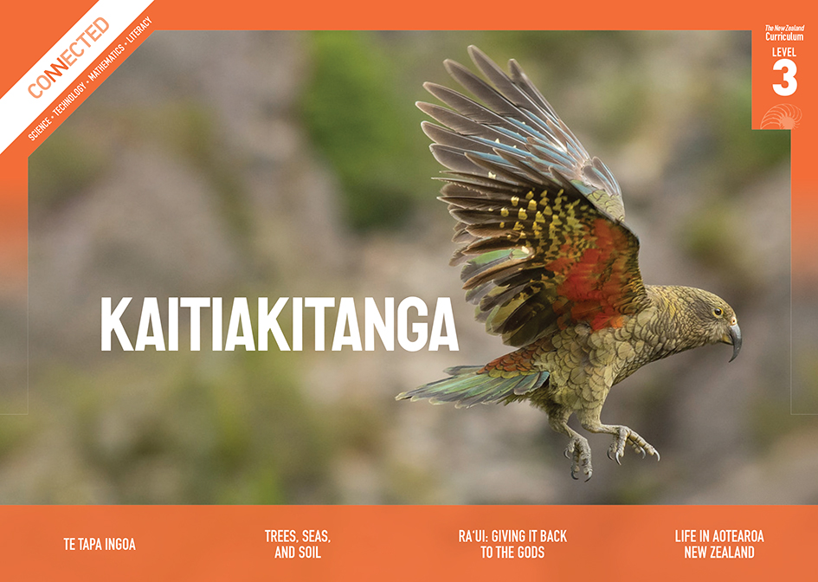
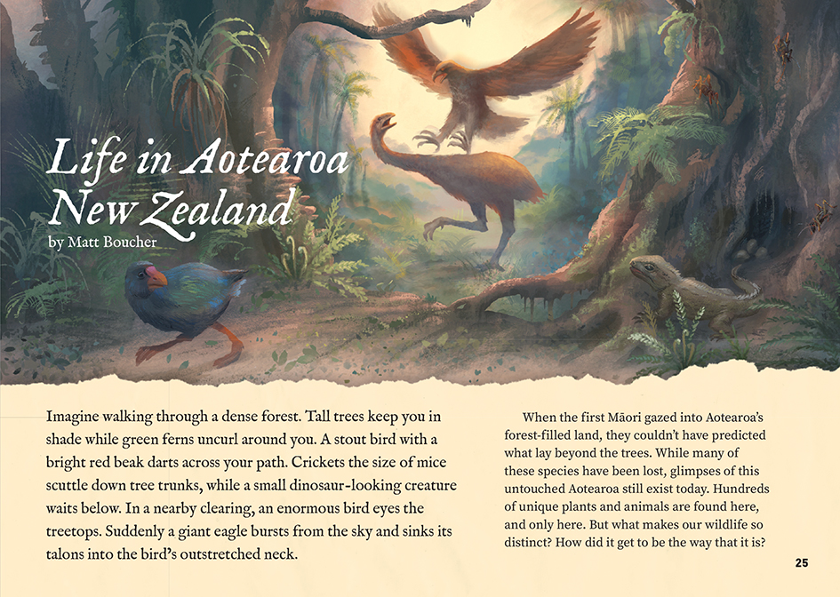

The Literacy Learning Progressions: Meeting the Reading and Writing Demands of the Curriculum describe the literacy-related knowledge, skills, and attitudes that students need to draw on to meet the demands of the curriculum.
The Learning Progression Frameworks (LPF) describe significant signposts in reading and writing as students develop and apply their literacy knowledge and skills with increasing expertise from school entry to the end of year 10.

Overview
This article describes the evolutionary development of life in Aotearoa New Zealand and addresses the question of why our flora and fauna are so distinct. It introduces and explains the concepts of evolution and adaptation and offers a brief overview of how the land itself changed over many millions of years.
A Google Slides version of this article is available at www.connected.tki.org.nz
This text also has additional digital content, which is available online at www.connected.tki.org.nz
Curriculum contexts

SCIENCE: Nature of Science: Understanding about science  Level 3 – Students will appreciate that science is a way of explaining the world and that science knowledge changes over time; students will identify ways in which scientists work together and provide evidence to support their ideas. | Key Nature of Science idea  Scientists:  - use evidence from fossils, geological records, and what they know about plants and animals living today to make inferences about what Earth and living organisms were like in the past.
SCIENCE: Living World: Evolution  Level 3 – Students will explore how the groups of living things we have in the world have changed over long periods of time and appreciate that some living things in New Zealand are quite different from living things in other areas of the world.  SCIENCE: Living World: Ecology  Level 3 – Students will explain how living things are suited to their particular habitat and how they respond to environmental changes, both natural and human-induced. | Key science ideas  - New Zealand’s long separation from other land masses has meant that the animals and plants that were present have been able to develop and adapt to the conditions here over many generations.  - A sudden change to conditions can mean that a highly adapted species can no longer survive.

ENGLISH: Reading
Level 3 – Ideas: Students will show a developing understanding of ideas within, across, and beyond texts.
Level 3 – Language features: Students will show a developing understanding of how language features are used for effect within and across texts.

The New Zealand Curriculum

Meeting the literacy challenges

The main literacy demands of this text arise from the complex, abstract concepts it explores and the extensive use of topic-specific language. However, each new idea is carefully introduced and connected to the previous section. The writer avoids too much detail and makes the concepts concrete by providing multiple examples. The chatty tone and use of colloquial language help make the content and new ideas accessible and engaging.  An asterisk is used to indicate a footnote that questions the established science, reflecting how it changes with new evidence. Breakout text and a diagram are provided to help students understand the enormous length of time that life on Earth has existed.  The following strategies will support students to understand, respond to, and think critically about the information and ideas in the text. | The instructional strategies below support students to meet the literacy challenges of this text. For each strategy, there are links to the relevant aspect of The Learning Progression Frameworks (Reading). The signposts on each of these aspects provide detailed illustrations on what to notice as your students develop their literacy knowledge and skills for different purposes in different curriculum areas.  You may wish to use shared or guided reading, or a mixture of both approaches, depending on the reading expertise of your students and the background knowledge they bring to the text.  After reading the text, support students to explore the activities outlined in the following pages.

INSTRUCTIONAL STRATEGIES

Building understanding of key ideas  [LPF Reading: Acquiring and using information and ideas in informational texts]  READ the first paragraph out loud and have the students sketch the image they have visualised, then have them check their sketches against the picture in the book. ASK QUESTIONS to help them think about the effect of that paragraph.  What did you see in your mind? What did you find in the picture?  Had you realised that this was a description of life in Aotearoa?  What questions do you have? What does it make you think of or wonder about?  Introduce the SQ3R reading method (Survey, Question, Read, Recite, Review). EXPLAIN that this is a technique that helps us train our minds to learn while we read. It involves:  - scanning the text to notice and record any important information from the title, introduction, headings, key words, breakouts, illustrations, photographs, and maps  - asking and recording questions that have arisen from your survey  - reading the text, writing answers to the questions as you finish each section, and adding any new questions that have emerged  - reciting – checking that you can recall (recite) the answers to your questions before you move to the next section  - reviewing your questions and answers and writing a summary.  Provide the students with a graphic organiser such as the one below for them to work through in pairs. | Life in Aotearoa New Zealand: SQ3R  Survey  Question  Read  Recite (recall)  Review and retell  Using the visual features to clarify the text  [LPF Reading: Making sense of text: using knowledge of text structure and features]  Remind the students of the visual features of the text that they surveyed before reading. As part of the review process, have pairs of students examine and report on one of these features. Ensure they consider the footnote on page 26. TELL the students that they are to explain:  - the purpose of their chosen feature  - where it links to the running text  - the information and/or ideas it shows  - things it made them think or wonder about  - how they made sense of it.

Meeting the literacy challenges

Dealing with topic-specific vocabulary  [LPF Reading: Making sense of text: vocabulary knowledge]  DISCUSS the fact that the writer’s primary purpose was to discuss the concepts of adaptation and evolution.  How did the writer help you to understand these concepts?  Why is it important to know about them?  Have the students create a word pyramid for each of these concepts. This involves:  - putting the word at the top of the pyramid  - putting the definition below the word  - putting synonyms or examples in the next layer  - writing a sentence in the bottom layer.  Reflecting on the reading process  [LPF Reading: Making sense of text: using a processing system]  PROMPT the students to reflect on how they used the various sources of information to actively engage with the text, make and check predictions, ask and answer questions, and clarify and extend their understandings.  How helpful were the headings in signalling the content?  Were your questions answered? Where did you find the answers?  What features of the text were most helpful or interesting?  What were the biggest challenges for you in reading this article?  Were there surprises? If so, what were they?  Have the students think, pair, and share their thoughts about whether the SQ3R method was helpful and when they could use it again. | Using critical literacy  [LPF READING: Making sense of text: reading critically]  DISCUSS the techniques used in the article to appeal to the reader.  The writer starts by asking us to imagine ourselves in a strange environment, hundreds of years ago. It’s not the normal introduction we expect from an article about science. Why do you think the writer did this? Are there other examples of language that don’t seem “scientific”? What impact does this have on you as a reader?  There are lots of adjectives in that first paragraph and a lot more in the rest of the article. Can you find them? Do you think these descriptive words are effective? What alternatives could you suggest?  If you were advising the writer or editor on how they could make this information more interesting or accessible for younger readers, what would you suggest?

The Learning Progression Frameworks
The Literacy Learning Progressions
Effective Literacy Practice: Years 5–8

Illustrating the key ideas

Some living things in New Zealand are quite different from living things in other areas of the world.  New Zealand’s long separation from other land masses has meant that the animals, and plants that were present have been able to develop and adapt to the conditions here over many generations. | 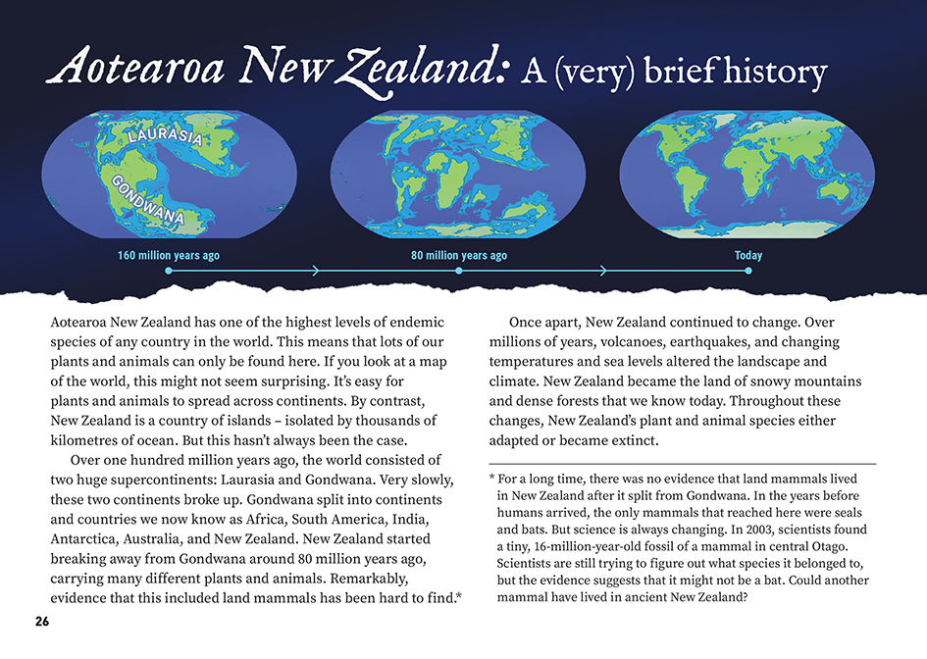  A sudden change to conditions can mean that a highly adapted species can no longer survive.  Scientists use evidence from fossils, geological records, and what they know about plants and animals living today to make inferences about what Earth and living organisms were like in the past.

Learning activities – Exploring the science

Activity 1 – Evolution: it takes time  Discuss how difficult it is to imagine the extraordinarily long time periods it takes for the land to change and for plants and animals to evolve. Have the students use an app (such as ReadWriteThink) to create an interactive timeline about the formation of New Zealand and the evolution of the creatures that live here. To do this, they will need to look for adverbs about time and place in the article.  Use this activity as a prompt to discuss which area the students would like to focus on and the information they would like to share. For example, they might focus on learning about and demonstrating:  - how Aotearoa changed position and shape over time  - how our plants and animals evolved, adapted, or became extinct  - the story of a particular species.  Discuss the ways they can effectively communicate this information, for example:  How could you give your audience an appreciation of the incredible time scale?  How will you make sure that they understand evolution, adaptation, or extinction?  What would be some good examples you could use to illustrate this?  What are some methods of communication that would suit your audience and topic?  Options could include:  - designing and building a more detailed interactive timeline  - creating a stop–motion animation that tells the history of a specific animal, from ancient times until now  - building a physical model of the world that shows how Laurasia and Gondwana slowly split up  - using the illustrations that accompany the article as a model for a mural that shows changes in New Zealand’s fauna at different times over the last 80 million years  - creating a series of freeze-frame images showing the changing land or the process of adaptation  - writing and presenting a short play about a day in the life of a young moa that illustrates how it is adapting to its environment  - writing and illustrating an article of their own that focuses on a specific creature.  The “Resource links” section below includes items that the students could use to help their research and to get ideas for how to present their information. However, they will also need to go further themselves.  Have the students present their text to another class and then evaluate how well they communicated their ideas about evolution and adaptation. | The following activities and suggestions are designed as a guide for supporting students to explore and extend their content knowledge across the learning areas. Adapt these activities to support your students’ interests and learning needs.  Extension  Have the students conduct a “what if” activity where they imagine a scenario where the evolutionary sequence did not happen as it did (for example, humans never arrived, moa did not die out, or tuatara increased in size). They could represent their ideas in “before and after” diagrams that incorporate statements explaining their ideas.  Activity 2 – Finding a niche  Remind the students that the article ends with a call to action: “What happens next is up to us.”  Have the students reread the section on “Finding a niche”. Then use the Science Learning Hub worksheet on classifying bird adaptations to extend their understanding of adaptations. They will learn from this that adaptations may be structural, behavioural, or physiological. The adaptations a creature has means that they are well-suited for living in their particular environment or ecological niche.  Discuss the fact that adaptations take a long time.  What might happen to a bird – or other animal or plant  – if we suddenly changed the environment around it?  What might happen if we moved it to a different environment?  Use the Science Learning Hub article on the takahē’s ecological niche to reinforce the idea that an “ecological niche is the role and position a species has in its environment and how the environment supports the species’ needs”. Have the students use the text in “Finding a niche” as a model for writing their own summary for how the takahē fits its niche.  Ask the students to share what they know about creatures in your local environment and the niche they fill. Have them work in groups to identify:  - the specific habitat where the creature lives  - the structural, behavioural, or physiological adaptations of the creature  - any threats to their survival  - any work that is being done to protect them.  There may be local experts who can help with this work, including environmentalists who are working to protect native and endemic species. The Department of Conservation and regional councils are good starting points for finding local conservation activities and taking responsibility for “what happens next”.  Extension  Participating in the New Zealand Garden Bird Survey provides a wonderful opportunity for students to explore the creatures in their own backyard, while learning about the nature of science and contributing positively as citizen scientists. This could become an annual commitment for the school.

RESOURCE LINKS

Connected and School Journal  “Squawkzilla”, Connected 2020, Level 2, Digging Deeper  “On the Move”, Connected 2016, Level 3, Picture This  “Listening to the Land”, Connected 2018, Level 3, Cracking the Code  Making Better Sense of the Living World  Science Focus: Classification (pages 22–42)  Building Science Concepts  Book 3: Birds: Structure Function and Adaptation  Science Learning Hub  Tectonic plates – Gondwana to modern NZ (video): https://www.sciencelearn.org.nz/videos/798-tectonic-plates  Native bird adaptations: https://www.sciencelearn.org.nz/resources/1162-native-bird-adaptations  Classifying bird adaptations: https://www.sciencelearn.org.nz/resources/1169-classifying-bird-adaptations  New Zealand native trees – an introduction: https://www.sciencelearn.org.nz/resources/2722-new-zealand-native-trees-an-introduction  The uniqueness of New Zealand plants: https://www.sciencelearn.org.nz/resources/2635-the-uniqueness-of-new-zealand-plants  Tuatara: https://www.sciencelearn.org.nz/resources/1382-tuatara  Our changing ecosystems – timeline: https://www.sciencelearn.org.nz/resources/1599-our-changing-ecosystems-timeline  Conserving our native kiwi: https://www.sciencelearn.org.nz/resources/2784-conserving-our-native-kiwi  Conserving native birds – introduction: https://www.sciencelearn.org.nz/resources/1158-conserving-native-birds-introduction  Wētā: https://www.sciencelearn.org.nz/resources/1962-weta  Darwin’s theory of evolution (video): https://www.sciencelearn.org.nz/videos/1711-darwin-s-theory-of-evolution  Moa were “plain Janes”: https://www.sciencelearn.org.nz/resources/1637-moa-were-plain-janes  Building homes for tree wētā: https://www.sciencelearn.org.nz/resources/1964-building-homes-for-tree-weta  What is a fern?: https://www.sciencelearn.org.nz/resources/1103-what-is-a-fern  New Zealand conservation and fungi: https://www.sciencelearn.org.nz/videos/754-new-zealand-conservation-and-fungi | The takahē’s ecological niche: https://www.sciencelearn.org.nz/resources/2702-the-takahe-s-ecological-niche  Planning pathways using takahē resources: https://www.sciencelearn.org.nz/image_maps/74-planning-pathways-for-takahe-resources  New Zealand Garden Bird Survey: https://www.sciencelearn.org.nz/resources/2732-new-zealand-garden-bird-survey  Te Ara  New Zealand breaks away from Gondwana: https://teara.govt.nz/en/geology-overview/page-6  Gondwana (image): https://teara.govt.nz/en/map/8296/gondwana  Species unique to New Zealand: https://teara.govt.nz/en/native-plants-and-animals-overview/page-1  Tuatara islands: https://teara.govt.nz/en/tuatara/page-2  Moa: https://teara.govt.nz/en/moa  Wētā: https://teara.govt.nz/en/weta  Tree ferns: https://teara.govt.nz/en/te-ngahere-forest-lore/page-3  Kākāpō: https://teara.govt.nz/en/large-forest-birds/page-5  Extinct, endangered, and threatened species: https://teara.govt.nz/en/land-birds-overview/page-4  DOC  New Zealand’s threatened birds: https://www.doc.govt.nz/nature/conservation-status/threatened-birds/  Conservation education: In your local environment (education resources): https://www.doc.govt.nz/get-involved/conservation-education/  Other  GNS Science: Pushing New Zealand’s boundaries (tectonic evolution of NZ [video]): https://www.youtube.com/watch?v=E6Nyr78Mqyg  Otago Museum: Long gone Gondwana (video and activity): https://otagomuseum.nz/athome/long-gone-gondwana  Endangered Species Foundation: Ten most endangered species: https://www.endangeredspecies.org.nz/projects/10-most-endangered  Predator Free NZ: Threatened species: https://predatorfreenz.org/about-us/pfnz-trust/threatened-species/  Forest and Bird: Native wildlife: https://www.forestandbird.org.nz/campaigns/native-wildlife  Let’s animate: Stop–motion animation technique https://www.tepapa.govt.nz/learn/for-educators/teaching-resources/children-tangaroa/lets-animate-stop-motion-animation

