Connected
Level 3
2020

Ra‘ui: Giving It Back to the Gods
by Monica Evans
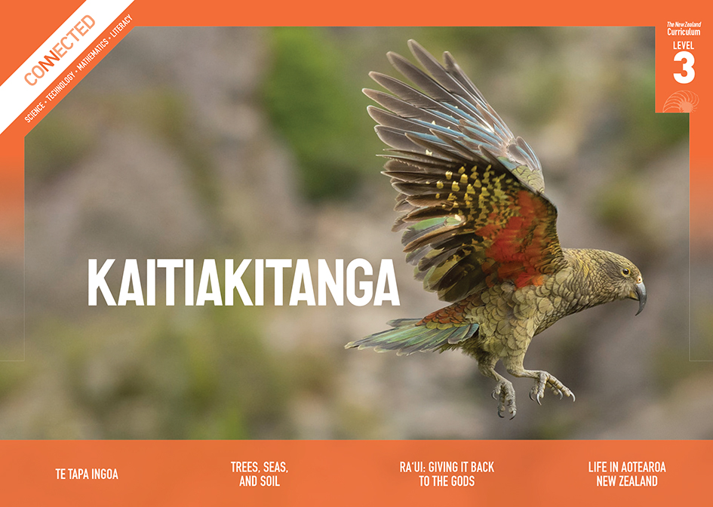
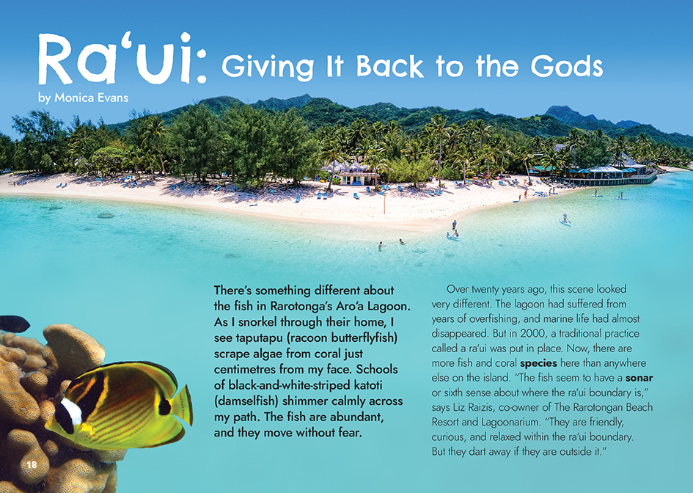

The Literacy Learning Progressions: Meeting the Reading and Writing Demands of the Curriculum describe the literacy-related knowledge, skills, and attitudes that students need to draw on to meet the demands of the curriculum.
The Learning Progression Frameworks (LPF) describe significant signposts in reading and writing as students develop and apply their literacy knowledge and skills with increasing expertise from school entry to the end of year 10.

Overview
This article explores a scientific issue from a Pacific worldview. It describes how the people of the Cook Islands have attempted to manage and protect their marine resources with the tradition of ra‘ui. The article highlights the very real issues that make success difficult and the diversity and validity of different people’s perspectives on ra‘ui.
A Google Slides version of this article is available at www.connected.tki.org.nz
Curriculum contexts

SCIENCE: Nature of Science: Understanding about science  Level 3 – Students will appreciate that science is a way of explaining the world and that science knowledge changes over time; students will identify ways in which scientists work together and provide evidence to support their ideas.  SCIENCE: Living World: Ecology  Level 3 – Students will explain how living things are suited to their particular habitat and how they respond to environmental changes, both natural and human-induced. | Key Nature of Science idea  Scientists:  - make observations and collect data over time that can help the community understand a situation or issue and guide the decisions they make about possible responses.  Key science ideas  - Animals and plants have adaptations that make them suited for living in their particular habitats.  - Animals and plants live in a dynamic relationship with each other; a change to conditions, such as overfishing of one species, can mean that other species go out of balance or struggle to survive.  - If we understand more about plants and animals, how they interact with each other, and what they need to live and reproduce, we can make changes to improve the chances of their survival as a species.

ENGLISH: Reading
Level 3 – Ideas: Students will show a developing understanding of ideas within, across, and beyond texts.
Level 3 – Language features: Students will show a developing understanding of how language features are used for effect within and across texts.

The New Zealand Curriculum

Meeting the literacy challenges

The concept of a ra‘ui is not complex. The complexity and challenge in this text arise from considering a range of perspectives and issues on ra‘ui and why some ra‘ui are successful and others are not.  A chatty and inquisitive narrator explains new concepts as they are introduced, and quotes from local people give the article an authentic, “real-world” appeal. However, as typical of quotes, they contain some longer, complex sentences, including some that begin with a conjunction.  The text includes some topic-specific vocabulary and names and terms in te reo Māori Kūkī ‘Āirani. These are explained within the text, often within brackets. Some students will be able to bring their expertise in te reo Māori Kūkī ‘Āirani to support others to understand and pronounce the words, and many will be able to draw on te reo Māori to make sense of these words. | The instructional strategies below support students to meet the literacy challenges of this text. For each strategy, there are links to the relevant aspect of The Learning Progression Frameworks (Reading). The signposts on each of these aspects provide detailed illustrations on what to notice as your students develop their literacy knowledge and skills for different purposes in different curriculum areas.  The following strategies will support students to understand, respond to, and think critically about the information and ideas in the text.  You may wish to use shared or guided reading, or a mixture of both approaches, depending on the reading expertise of your students and the background knowledge they bring to the text.  After reading the text, support students to explore the activities outlined in the following pages.

INSTRUCTIONAL STRATEGIES

Previewing the text  [LPF Reading: Making sense of text: using knowledge of text structure and features]  PROMPT the students to read the title, scan the headings, and examine the maps and photographs to get a sense of what the article is about and what the context is. ASK QUESTIONS to help them make connections to their prior knowledge and make inferences about what makes the Cook Islands’ marine environment special and why it should be protected.  What does the title suggest the article is about? What clues do you get from the headings?  Do you recognise the word “ra‘ui”? What do you think it means?  There are two maps in this article. What do they each show? Why do you think they are there?  What do the photographs tell you about the Cook Islands? What do they suggest about what matters to people there?  What do you know about the Cook Islands? Do the photographs match your experiences or what you have seen, read, or heard about the Cook Islands?  Using text features to find information  [LPF Reading: Making sense of text: using knowledge of text structure and features]  Ask the students to reread a section of the text containing a quote from one of the interviewees. Prompt them to use the punctuation and text markers to distinguish between the running text and the quoted section. Explain that sometimes a long complex sentence in a quote is broken up with “she says” or “says …” Prompt students to use punctuation and meaning to find the main clause (the part that makes sense alone and could be a complete sentence) and details in the supporting phrase (which isn’t a complete sentence). | What helps you to follow the ideas and information in a complex sentence?  What do you notice about the differences between the language in some of the quotes and the rest of the text?  Why have the quotes been included?  What might trip you up when you read quotes in an article like this?  Building understanding  [LPF Reading: Acquiring and using information and ideas in informational texts]  Have the students read the first two paragraphs. ASK QUESTIONS to help them check their inferences about what a ra‘ui might be and have them share any prior knowledge of ra‘ui.  From what you have seen and read so far, what do you think a ra‘ui is? Why do people have it? What are the connections to Māori cultural practices?  Ra‘ui sound like very good things. What challenges or issues might people face in keeping them going?  Have the students use a PMI chart to RECORD what they learn about ra‘ui and about the challenges and issues that can be associated with them.  Plus Minus Interesting (or Implications)

Meeting the literacy challenges

Using critical literacy  [LPF Reading: Making sense of the text: reading critically]  Have the students use their PMI charts to IDENTIFY the key issues around the establishment and maintenance of ra‘ui and the different groups that have an interest in them. (These include scientists, politicians, cultural elders, local businesspeople, local fishermen, students, miners, and future generations.) EXPLAIN, if necessary, that we call these people “stakeholders”.  Have the students work in pairs to select one group of stakeholders and reread the article with the intention of understanding the perspective of people within that group. ASK QUESTIONS to help them empathise with people’s situations and concerns.  Who are these people? What is their point of view? What does the writer tell you about their concerns and their values? What can you work out from the quotes? Why has the writer chosen these quotes to include in the text?  Imagine you are in these people’s shoes. How do you think you would be feeling about the ra‘ui? What might worry you? Or excite you?  Do you suppose everybody within each of these groups will have the same perspective? What might have not been included?  What does the author think about these issues? How can you tell?  Have the students explore these perspectives by either:  - conducting a hot-seating activity in which some of the students go into roles as members of the interest groups, and others as reporters to ask questions about why people do or do not support the ra‘ui; or  - having them take on the stance of one of the interest groups and debate whether seabed mining should be allowed within Marae Moana. | Dealing with unfamiliar vocabulary  [LPF Reading: Making sense of text: vocabulary knowledge]  Have the students create concept maps for the words “ra‘ui”, “rāhui”, and “marine protected area”. PROMPT them to compare the three concepts, a task that may require some additional research.  What are the “principles of a ra‘ui”?  How are these applied to the creation of a marine protected area?  What is different about applying these indigenous values and customs to a modern world?  Students are likely to have made connections between the words “ra‘ui” and “rāhui” and have noticed similarities between the words in te reo Māori Kūkī ‘Āirani and te reo Māori. DISCUSS that these similarities arise from the fact that Māori arrived in New Zealand from Hawaiki, a place that may also be the origin of te reo Māori Kūkī ‘Āirani. Have the students create a table that compares the words in te reo Māori Kūkī ‘Āirani with their counterpart in te reo Māori.  Students may be puzzled by the glottal stop in ra‘ui. EXPLAIN that most words in te reo Māori Kūkī ‘Āirani have a similar pronunciation to te reo Māori. However, like some other Pacific languages, it also includes the glottal stop. The glottal stop works as another consonant and is made by closing the flow of air in the throat.  Some students may be intrigued by the glottal stop and wonder whether it is used in languages beyond the Pacific. Pronunciation Studio has a guide to the glottal stop that could be the base for exploring whether it is also used in New Zealand.

The Learning Progression Frameworks
The Literacy Learning Progressions
Effective Literacy Practice: Years 5–8

Illustrating the key ideas

If we understand more about plants and animals we can make changes to improve the chances of their survival as a species.
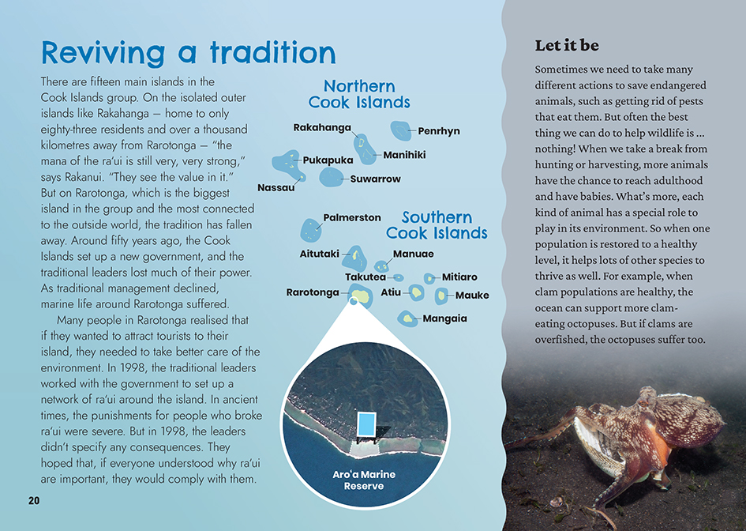
When the community understand a situation or issue they can make decisions about possible responses.
Animals and plants live in a dynamic relationship with each other; a change to conditions can mean that other species go out of balance or struggle to survive.

Learning activities – Exploring the science

Activity 1 – Protecting our place  Have the students plan and carry out an investigation into sanctuaries and rāhui within their local environment. Their investigations could incorporate inquiry into:  - what motivated the establishment of the rāhui, or sanctuary  - people’s perspectives before and after the establishment of the rāhui  - what the rules are, how they are enforced, and the extent to which people are abiding by them  - issues, problems, and solutions  - the success of the rāhui.  Have the students use the resource on Te Ara to understand the different kinds of sanctuary and rāhui that exist, their purpose, and their advantages and disadvantages. Some students may also be aware of covenants placed on private land. If they are unsure, the QEII National Trust website includes a map. Use this discussion as a springboard for identifying a local place that is under protection.  Ideally, the investigation would include a visit to the rāhui, sanctuary, or covenanted land and the opportunity to contribute to its protection. Most of the Connected articles listed below have suggestions for how students can engage in citizen science.  A newer opportunity is provided by Sustainable Coastline’s Litter Intelligence Survey. The Litter Intelligence Project works from the premise that “we can’t improve what we don’t measure”. It offers a database for learning about the litter that is entering the marine environment. Students can explore the database to learn about what is happening at a beach near them. In many places, there will be the opportunity to participate in a litter survey; in fact, schools could establish them. Through this process, the students will learn about the importance of scientific rigour when collecting, measuring, and recording the litter.  If the students visit private land that has been placed under covenant, they could learn about the economic and social costs and benefits of doing this. The kawenata (covenant) placed on Owhaoko land provides a good example of how land and wildlife can be protected while also being economically and socially productive.  Have the students conclude their investigation by creating posters, infographics, or digital presentations that summarise what they have learned and encourage people, in a tactful and positive way, to play their part in ensuring that their local rāhui, sanctuary, or QEII National Trust covenant is successful. | The following activities and suggestions are designed as a guide for supporting students to explore and extend their content knowledge across the learning areas. Adapt these activities to support your students’ interests and learning needs.  Extension  In the text, Tou Ariki cites his ancestors as saying, “you protect and then you harvest”. Discuss how well this encapsulates the main ideas in the text. Prompt the students to make connections to their own cultural traditions around care for the environment. These may be encapsulated in whakataukī, sayings, or in day-to-day practices that people may not even be conscious of performing (such as a family habit of emptying the teapot onto the garden). Have the students reach out to whānau and community to learn more.  Activity 2 – Let it be  Have the students revisit the sidebar headed “Let it be”. Discuss the idea that each animal has a special role to play in the environment. Explore the example that if there are plenty of clams in the ocean, then clam-eating octopuses can thrive, but when the number of clams decline, then so too do the numbers of octopuses. Explain that this is an example of a food chain and have the students sketch it.  Use the Science Learning Hub article on marine food webs to introduce the concept of a food web and compare it with that of a food chain. The article has an interactive diagram that the students can use to learn about different parts of the marine ecosystem. Use the accompanying activity to engage them in building their own marine food web and exploring the impact of reducing or removing one of the species. Alternatively, you could use the Building Science book on tidal communities and the Science Online activity on “Constructing diagrams of food chains” to support the students to construct a food chain or web and show the connections of creatures on the rocky shore.  Present the students with cards of potential scenarios for different ecosystems. Scenarios might include:  - a forest that has been flattened by a storm  - a vegetable or flower garden that has been left alone  - a school field that is left unmown  - a local stream that is fenced off  - an abandoned farm  - a burnt-out patch of bush.  Have the students move into groups to:  - research and draw a food web that represents some of the key relationships that exist between organisms in that ecosystem  - find evidence to predict what would happen if the organisms in that environment were left to themselves  - discuss or debate whether it would be best to “let it be”.
Have the students share their diagrams and predictions with the rest of the class, supporting their presentations with evidence from their research. Organise the class to challenge the presenters with the perspectives of different people in the community and to consider the issues that may arise. Record their suggestions, which might include:  - pests invading or spreading out of the sanctuary  - grass growing too long and becoming a fire hazard  - safety concerns requiring a new road.  Perspectives might include those of people who:  - are concerned about the loss of a food source for humans  - are concerned about the impact on their livelihood or the wider economy  - value the beauty of a well-tended garden  - believe children should be able to fish in their local waterways.  Have the students move back into their groups to complete PMI charts that summarise the advantages and disadvantages of not interfering with their allotted ecosystem, considering a range of perspectives. Move the students towards an understanding that we are part of the ecosystem, too, and so what we do – or don’t do – matters. | Extension  Have the students read “After the Spill” to understand how the Rena oil spill impacted the creatures that live on Ōtāiti or Astrolabe Reef off the Tauranga coast. Discuss and compare the way indigenous knowledge and knowledge from “the modern world” interact in both this example and ra‘ui in the Cook Islands as people seek to put protective measures around the natural environment.

RESOURCE LINKS

Connected and School Journal  “The Fish Highway”, Connected 2013, Level 3, Food for Thought  “After the Spill”, Connected 2013, Level 4, Are You Sure?  “Rising Seas”, Connected 2014, Level 3, Why Is That?  “Counting Kākahi”, Connected 2014, Level 3, Why Is That?  “Learning from the Tangata Whenua”, Connected 2015, Level 2, Have You Checked?  “What Now for the Rena?”, Connected 2016, Level 4, Getting the Message  “Listening to the Land”, Connected 2018, Level 3, Cracking the Code  “Under the Sea”, Connected 2018, Level 4, Digital Space  “Rāhui”, Junior Journal 58, Level 2, 2019  Building Science Concepts  Book 22: Tidal Communities: Interdependence and the Effects of Change  Science Learning Hub  Ecosystem overfishing (image): https://www.sciencelearn.org.nz/images/1276-ecosystem-overfishing  Human impacts on marine environments: https://www.sciencelearn.org.nz/resources/144-human-impacts-on-marine-environments  Marine food webs: https://www.sciencelearn.org.nz/resources/143-marine-food-webs  Build a marine food web: https://www.sciencelearn.org.nz/resources/1525-build-a-marine-food-web  Rāhui Pōkeka (video): https://www.sciencelearn.org.nz/videos/259-rahui-pokeka  Restoring mauri after the Rena disaster: https://www.sciencelearn.org.nz/resources/809-restoring-mauri-after-the-rena-disaster | Science Online  Constructing diagrams of food chains: https://scienceonline.tki.org.nz/Nature-of-science/Nature-of-Science-Teaching-Activities/Constructing-diagrams-of-food-chains  Te Ara  Cook Islanders: https://teara.govt.nz/en/cook-islanders  The Cook Islands (map): https://teara.govt.nz/en/map/849/the-cook-islands  Rāhui – prohibitions: https://teara.govt.nz/en/kaitiakitanga-guardianship-and-conservation/page-6  Wildlife sanctuaries: https://teara.govt.nz/en/map/11932/wildlife-sanctuaries  Marae Moana  Marine park map: https://www.maraemoana.gov.ck/about-marae-moana/marine-park-map/  What is Marae Moana?: https://www.maraemoana.gov.ck/about-marae-moana/what-is-marae-moana/  Other  Ministry of Marine Resources Cook Islands: Ra‘ui (Marine Protected Areas): https://www.mmr.gov.ck/raui-marine-protected-areas/  QEII National Trust: Benefits of protecting your land: https://qeiinationaltrust.org.nz/protecting-your-land/  Pronunciation Studio: The gloʔal whaʔ – A pronunciation guide to the glottal stop https://pronunciationstudio.com/glottal-stop-pronunciation-guide/  Drama teachers’ toolkit: How to improve hot-seating to achieve better learning in your lesson: https://burtsdrama.com/2012/06/06/improvehotseating/  Litter intelligence: https://litterintelligence.org/

