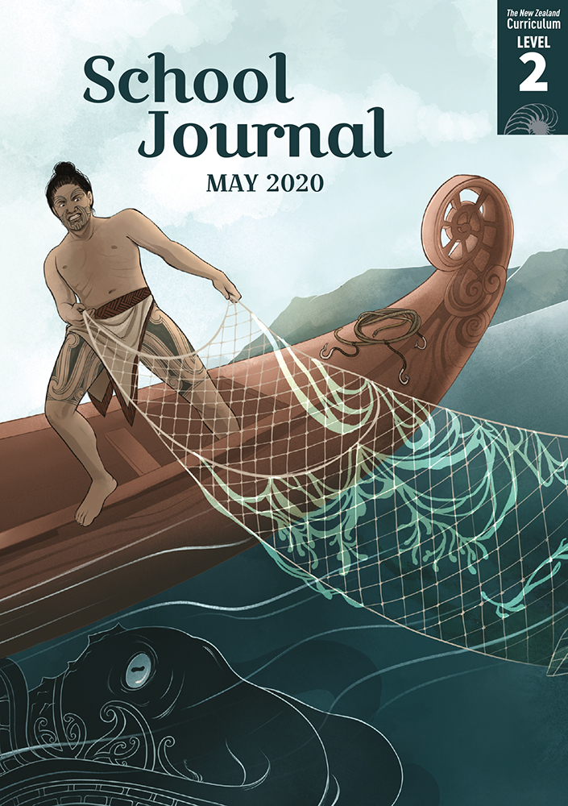

School Journal

Level 2, May 2020

**Year 4**

# Monsters

by Tricia Glensor

The[Learning Progression Frameworks](https://curriculumprogresstools.education.govt.nz/lpf-tool) describe significant signposts in reading and writing as students develop and apply their literacy knowledge and skills with increasing expertise from school entry to the end of year 10.

## Overview

This article describes a selection of mythical creatures and monsters from around the world, including Kāhui Tipua (Aotearoa), Afinemata/Gāhehelevao (Tokelau), kraken (Norway), oni (Japan), sphinx (Ancient Greece and North Africa), dragons   
(Asia and Europe), chinthe (Myanmar/Cambodia/Laos), and the bunyip (Australia), and discusses the possible origins   
of such creatures and some of the reasons for their universal appeal.

A PDF of the text and an audio version as an MP3 file are available at [www.schooljournal.tki.org.nz](http://www.schooljournal.tki.org.nz)

## Theme

* Cultural beliefs

## Related texts

“**Kurī**” SJ L2 Oct 2015 | “**The Sons of Ma‘afu**” SJ L2 Oct 2015 | “**Awarua: The Taniwha of Porirua**” SJ L2 May 2016 |   
“**Baskets of Fire**” SJ L2 Nov 2018 | “**Kupe and the Giant Wheke**” SJ L2 May 2020 | “**Kōpūwai and the Clever Girl**” SJ L3 May 2017 |   
“**Nian, the New Year Monster**” *JJ* 59

## Strengthening reading behaviours (what to notice)

|  |  |
| --- | --- |
| Text structure and features | Requiring students to: |
| * Non-fiction text in short sections with subheadings and photographs * Implied information or ideas and some abstract ideas * Some non-English words and phrases | * make connections between various sources of information * make connections to other stories about monsters and make inferences about the features of monsters and the various reasons for creating them * use resources such as maps, their word knowledge, prior knowledge, and context clues to work out unfamiliar vocabulary. |

|  |  |
| --- | --- |
| Vocabulary | |
| Possibly unfamiliar words and phrases, including some  non-English words | roam, countryside, lie in wait, fierce, according to, stride, prowls, misbehave, tucked up, kanabō, roasted soybeans, Oni wa soto!, riddle, guarded, tombs, Great Pyramid, scales, slither, knight, reassure, terrifying, special occasions, swamps, temples, Aboriginal, billabongs, face up to |
| Names of monsters from around  the world | Kāhui Tipua, Afinemata/Gāhehelevao, kraken, oni, sphinx, dragon, chinthe, bunyip |
| Names of countries | Aotearoa, Tokelau, Norway, Scandinavia, Japan, Greece, Africa, Egypt, England, Australia, Myanmar, Cambodia, Laos |

|  |
| --- |
| Helpful prior knowledge (pre-reading and introducing the text) |
| * Every culture has its own monsters or mythical creatures. * There can be many versions of traditional tales – some versions can contradict others. * Some traditional tales may try to explain natural phenomena. * Monsters can be both good and bad. |

## Possible reading and writing purposes

* Find out about monsters in some cultures
* Identify and record the similarities and differences between some of the monsters in the text
* Explore why people have stories about monsters in their culture
* Think about and ask questions related to the text to prompt further investigation

See *Effective Literacy Practice in Years 1–4* for suggestions on using this text with your students ([Approaches to teaching reading](http://literacyonline.tki.org.nz/Literacy-Online/Planning-for-my-students-needs/Effective-Literacy-Practice-Years-1-4/Approaches-to-teaching-reading)) and for information about teaching comprehension strategies ([Building comprehension](http://literacyonline.tki.org.nz/Literacy-Online/Planning-for-my-students-needs/Effective-Literacy-Practice-Years-1-4/Building-comprehension) and [Text processing strategies](http://literacyonline.tki.org.nz/Literacy-Online/Planning-for-my-students-needs/Effective-Literacy-Practice-Years-1-4/Text-processing-strategies)).

## Possible curriculum contexts

This text has links to level 2 of the New Zealand Curriculum in:[**ENGLISH**](http://nzcurriculum.tki.org.nz/The-New-Zealand-Curriculum/English)[**SOCIAL SCIENCES**](http://nzcurriculum.tki.org.nz/The-New-Zealand-Curriculum/Social-sciences)

## Understanding progress

The following aspects of progress are taken from the [Learning Progression Framework](https://curriculumprogresstools.education.govt.nz/lpf-tool/)s and relate to the specific learning tasks below. See the LPFs for more about how students develop expertise and make progress in these aspects:

* Acquiring and using information and ideas in informational texts
* Reading to organise ideas and information for learning.

## Strengthening understanding through reading and writing

The *School Journal* provides rich texts that can be returned to many times. The following suggestions are based on the premise that rereading the text is a fundamental part of developing students’ understanding and reading skills. **Select from and adapt** them according to your students’ strengths, needs, and experiences.   
Note: Most of these activities lend themselves to students working in pairs or small groups.

* Review the features of non-fiction texts and ask the students to reflect on what they found out, what they related to (made a connection with), and questions they have after reading. They could use the **432 FCQ** template provided (4 facts they found out,   
  3 connections they made, 2 questions they have).
* Have the students find answers to one of their questions and present what they have discovered to the group through a poster, an interview script, or a news report, for example, motivated by <https://www.stuff.co.nz/national/kea-kids-news>.   
   The students could use Google Slides to create their poster.
* Ask the students to compare two of the monsters by recording information on a T-chart or Venn diagram.
* Copy the images of the different monsters and give them to pairs of students. The students take turns to describe their monster until the other guesses what it is. Using the PDF and Google slides, create cards of each monster.
* Have the students describe some of the qualities and features of a monster. Encourage them to give their own opinions of whether they are good or bad as well as reasons why monster stories exist in many cultures.
* Explore the reasons why the author thinks there are so many stories about monsters. Use a highlighter pen (or display this section on a screen) to copy the parts on page 7 that help answer this. You could focus on how to pull out key words and record them as notes, adding their own ideas if they wish. The students could then write a sentence or two summarising these points.
* Have the students design their own monster with bullet point facts about it and then use these bullets to write a summarising sentence or two.  You could direct students to a Pinterest page with a selection of monsters to inspire them.   
  They could illustrate their monster or make a model, puppet, or mask of it.   
   <https://www.wikihow.com/Create-Your-Own-Monster-Character> is a great step-by-step program students could use to create a monster.
* Have the students write a fiction story, featuring one of the monsters described in the article, such as “a day in the life of the bunyip” or “when the sphinx came to school”.
* Ask the students to create an indoor or outdoor game based on one of the monsters and write the instructions for playing the game.
* To explore vocabulary, you might create a cloze activity by copying a section of text, blanking out certain words, and providing a list of the words for the student to fill in, for example, Afinemata/Gāhehelevao (on page 3) or Oni (on page 4).
* For more ideas and strategies to support English language learners, see [ESOL Online](https://esolonline.tki.org.nz/).

“Monsters” 432 FCQ

C

C

|  |  |  |
| --- | --- | --- |
| **F** |  | **F** |
|  |  |  |
| **F** |  | **F** |

**Q**

**Q**

C

**F** What I found out **C** Connections I made **Q** Questions I have